ME 2041 - ADVANCED I.C. ENGINES

ME2041 - ADVANCED IC ENGINES

UNIT-I

SPARK IGNITION ENGINES

Introduction about IC engines

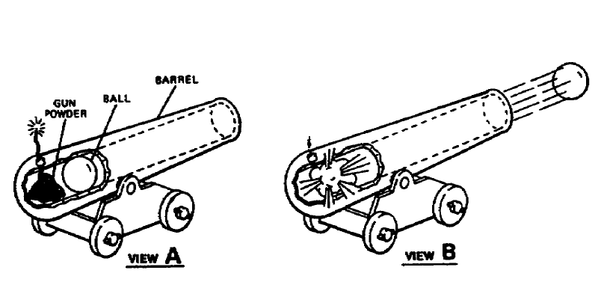
The operation of the piston engine can best be understood by comparing it to a simple cannon. In view A of figure 1 on the following page, a cannon barrel, charge of gunpowder, and a cannonball are illustrated. In view B of figure 1, the gunpowder is ignited. The gunpowder burns very rapidly and as it burns there is a rapid expansion of the resulting gases. This rapid expansion causes a tremendous increase in pressure that forces the cannonball from the barrel.

Now the cannon barrel has been replaced by a cylinder and a combustion chamber. The

cannonball has been replaced by a piston. A mixture of vaporized fuel and air has replaced the gunpowder. In view B of figure, the gasoline is ignited. This time, the resulting force acts to push the piston downward.

COMPILED BY: SP.ARUNKUMAR, AP (Sr.Gr)/MECH

SRI RAMAKRISHNA INSTITUTE OF TECHNOLOGY, PACHAPALAYAM, COIMBATORE-10. 1 out of 99

ME 2041 - ADVANCED I.C. ENGINES

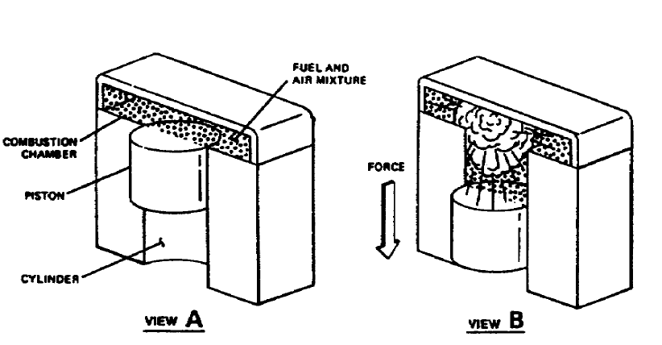

The force of the piston acting in a downward notion is of little immediate value if it is to turn

the wheels of a vehicle. In order to use this straight line or reciprocating motion, it must be transformed into rotary motion. This is made possible through the use of a crankshaft. The crankshaft is connected to the driving wheels of a vehicle throughthe drive train on one end. On the other end of the shaft is a crank with acrankpin offset from the shaft's centre. Figure below illustrates how the piston and the crankshaft are connected through the connecting rod and the crankpin. Figure below on the following page illustrates how reciprocating motion of the piston is changed to rotating motion of the crankshaft.

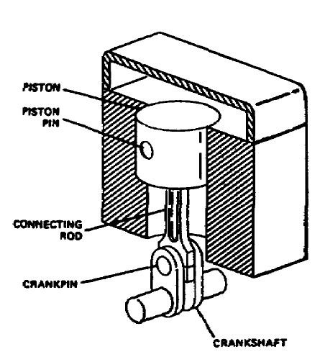

COMPILED BY: SP.ARUNKUMAR, AP (Sr.Gr)/MECH

SRI RAMAKRISHNA INSTITUTE OF TECHNOLOGY, PACHAPALAYAM, COIMBATORE-10. 2 out of 99

ME 2041 - ADVANCED I.C. ENGINES

Air-fuel ratio requirements

The task of the engine induction and fuel systems is to prepare from ambient air and fuel in the tank an air-fuel mixture that satisfies the requirements of the engine over its entire operating regime. In principle, the optimum air/fuel ratio for a spark-ignition engine is that which gives the required power output with the lowest fuel consumption, consistent with smooth and reliable operation. In practice, the constraints of emissions control may dictate a different air/fuel ratio, and may also require the recycling of a fraction of the exhaust gases (EGR) into the intake system. The relative proportions of fuel and air that provide the lowest fuel consumption, smooth reliable operation, and satisfy the emissions requirements, at the required power level, depend on engine speed and load. Mixture requirements and preparation are usually discussed in terms of the air/fuel ratio 0' fuel/air ratio and percent EGR. While the fuelmetering system is designed to provide the appropriate fuel flow for the actual air flow at each speed and load, the relative proportions of fuel and air can be stated more generally in terms of the fuel/air equivalence ratio, which is the actual fuel/air ratio normalized by dividing by the stoichiometric fuel/air ratio. The combustion characteristics of fuel-air mixtures and the properties of combustion products, which govern engine performance, efficiency, and emissions, correlate best for a wide range of fuels relative to the stoichiometric mixture proportions. Where appropriate, therefore, the equivalence ratio will be used as the defining parameter. A typical value for the stoichiometric air/fuel ratio of gasoline is 14.6.t Thus, for gasoline,

A briefsummary is sufficient here. Mixture requirements are different for full-load

(wideopenthrottle) and for part-load operation. At the former operating condition, complete utilization of the inducted air to obtain maximum power for a given displaced volume is the critical issue. Where less than the maximum power at a given speed is required, efficient utilization of the fuel is the critical issue. At wide-open throttle, maximum power for a given volumetric efficiency is obtained with rich-of- stoichiometric mixtures, 4 X1.1. Mixtures that are richer still are sometimes used to increase volumetric efficiency by increasing the amount of charge cooling that accompanies

COMPILED BY: SP.ARUNKUMAR, AP (SR.GR)/MECH

SRI RAMAKRISHNA INSTITUTE OF TECHNOLOGY, PACHAPALAYAM, COIMBATORE-10. 3 out of 99

ME 2041 - ADVANCED I.C. ENGINES

fuel vaporization, thereby increasing the inducted air density. At part-load (or part-throttle) operating conditions, it is advantageous to dilute the fuel-air mixture, either with excess air or with recycled exhaust gas. This dilution improves the fuel conversion efficiency for three reasons:' (1) the expansion stroke work for a given expansion ratio is increased as a result of the change in thermodynamic properties of the burned gases-see Sees. 5.5.3 and5.7.4; (2) for a given mean effective pressure, the intake pressure increases with increasing dilution, so pumping work decreases; (3) the heat losses to the walls are reduced because the burned gas temperatures are lower. In the absence of strict engine NO, emission requirements, excess air is the obvious diluents, and at part throttle engines have traditionally operated lean. When tight control of NO,, HC, and CO emissions is required, operation of the engine with a stoichiometric mixture is advantageous so that a three-way catalyst can be used to clean up the exhaust. The appropriate diluent is then recycled exhaust gases which significantly reduces NO, emissions from the engine itself. The amount of diluent that the engine will tolerate at any given speed and load depends on the details of the engine's combustion process. Increasing excess air or the amount of recycled exhaust slows down the combustion process and increases its variability from cycle to cycle. A certain minimum combustion repeatability or stability level is required to maintain smooth engine operation. Deterioration in combustion stability therefore limits the amount of dilution an can tolerate. As load decreases, less dilution of the fresh mixture can be tolerated because the internal dilution of the mixture with residual gas increases. At idle conditions, the fresh mixture will not usually tolerate any EGR and may need to be stoichiometric or fuel-rich to obtain adequate combustion stability.
If stoichiometric operation and EGR are not required for emissions control, as load increases the mixture is leaned out from a fuel-rich or close-to-stoichiometric composition at very light load. As wide-open throttle operation is approached at each engine speed, the mixture is steadily enriched to rich-of-stoichiometric the maximum point. With the stoichiometric operating conditions required for three-way-catalyst-equipped engines, when EGR is used, the percentage of recycled exhaust increases from zero at light load to a maximum at mid-load, and then decreases to zero as wide-open throttle conditions are approached so maximum break can be obtained. Combinations of these strategies are possible. For example, lean operation at light load can be used for best efficiency, and

COMPILED BY: SP.ARUNKUMAR, AP (SR.GR)/MECH

SRI RAMAKRISHNA INSTITUTE OF TECHNOLOGY, PACHAPALAYAM, COIMBATORE-10. 4 out of 99

ME 2041 - ADVANCED I.C. ENGINES

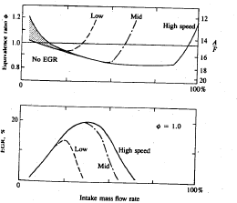
Typical mixture requirements for two common operating strategies: Top diagram shows equinlence ratio variation with intake mass flow rate (percent of maximum flow at rated speed) at constant low and high engine speeds. Bottom diagram shows recycled exhaust (EGR) schedule as a function of intake flow rate, for low, mid, and high speeds for stoichiometric operation.

Stoichiometric mixtures (with a three-way catalyst) and/or EGR can be used at mid loads to control NO, emissions. In practical spark-ignition engine induction systems, the fuel and air distribution between engine cylinders is not uniform (and also varies in each individual cylinder on a cycle-by-cycle basis). A spread of one or more air/fuel ratio between the leanest and richest cylinders over the engine's load and speed range is not uncommon in engines with conventional carburetors. The average mixture composition must be chosen to avoid excessive combustion variability in the leanest operating cylinder. Thus, as the spread in mixture no uniformity increases. The mean equivalence ratio must be moved toward stoichiometric and away from the equivalence ratio which gives minimum fuel consumption.

COMPILED BY: SP.ARUNKUMAR, AP (SR.GR)/MECH

SRI RAMAKRISHNA INSTITUTE OF TECHNOLOGY, PACHAPALAYAM, COIMBATORE-10. 5 out of 99

ME 2041 - ADVANCED I.C. ENGINES

Design of carburettor

Carburetor Fundamentals

A carburetor has been the most common device used to control the fuel flow into the intake manifold and distribute the fuel across the air stream. In a carburetor the air flows through a converging-diverging nozzle called a venturi. The pressure difference set up between the carburetor inlet and the throat of the nozzle (which depends on the air flow rate) is used to meter the appropriate fuel flow for that air flow. The fuel enters the air stream through the fuel discharge tube or ports in the carburetor body and is atomized and convicted by the air stream past the throttle plate and into the intake manifold.
Fuel evaporation starts within the carburetor and continues in the manifold as fuel droplets move with the air flow and as liquid fuel folks over the throttle and along the manifold walls. A modem carburetor which meters, the appropriate fuel flow into the air stream over the complete engine operating range is a highly developed and complex device. There are many types of carburetors; they share the same basic concepts which we will now examine.

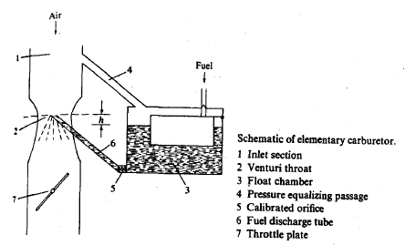

Figure shows the essential component of an elementary carburetor.The air enters the intake section of the carburetor (1) from the air cleaner which removes suspended dust particles.The air then flows into the carburetor venture (a converging-diverging nozzle)(2) where the air

COMPILED BY: SP.ARUNKUMAR, AP (SR.GR)/MECH

SRI RAMAKRISHNA INSTITUTE OF TECHNOLOGY, PACHAPALAYAM, COIMBATORE-10. 6 out of 99

ME 2041 - ADVANCED I.C. ENGINES

velocity increases and the pressure decrease. The fuel level is maintained at a constant height in the float chamber (3) which is connected 'via an air duct (4) to the carburetor intake section (I). The fuel flows through the main jet (a calibrated orifice) (5) as a result of the pressure difference between the float chamber and the venturi throat and through the fuel discharge nozzle (6) into the venturi throat where the air stream atomizes the liquid fuel. The fuel-air mixture flows through the diverging sectionof the venturi where the flow decelerates and some pressure recovery occurs. The flow then passes the throttle valve (7) and enters the intake manifold. Note that the flow may be unsteady even when engine load and speed are constant, due- to the periodic filling of each of the engine cylinder which draws air through the carburetor venturi. The induction time, 1/(2N) (20 ms at 1500 rev / min) is the characteristic time of this periodic cylinder filling process. Generally, the characteristic times of changes in throttle setting are longer; it takes several engines operating cycles to re-establish steady-state engine operation after a sudden change in throttle position. It is usually assumed that the flow processes in the carburetor can be modelled as quasi steady.

Venture size

Carburetor venturi size is usually designed by the conventional equation for better performance even though some modern design has changed over the performance of carburetor in the present scenario.

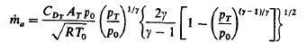

where CDT and AT are the discharge coefficient and area of the venturi throat, respectively. If we assume the velocity at the carburetor inlet can be neglected, the above equation can be rearranged in terms of the pressure drop from upstream conditions to the venturi throat for the air stream, Δpa = po - pT, as
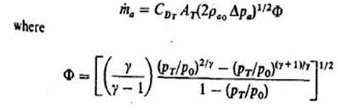

COMPILED BY: SP.ARUNKUMAR, AP (SR.GR)/MECH

SRI RAMAKRISHNA INSTITUTE OF TECHNOLOGY, PACHAPALAYAM, COIMBATORE-10. 7 out of 99

ME 2041 - ADVANCED I.C. ENGINES

and accounts for the effects of compressibility. For the normal carburetor operating range, where Δpa / po<=0.1, the effects of compressibility which reduce Фbelow 1.0 are small.

Fuel jet size

Since the fuel is a liquid and therefore essentially incompressible, the fuel flow rate

through the main fuel jet is given by

Where CDo and Ao, are the discharge coefficient and area of the orifice, respectively, Δpf, is the pressure difference across the orifice, and the orifice area isassumed much less than the passage area. Usually, the fuel level in the floatchamber is held below the fuel discharge nozzle, as shown in Fig, to preventfuel spillage when the engine is inclined to the horizontal (e.g., in a vehicle on a slope). Thus

Where h is typically of order 10mm.

The discharge coefficient CDo in fuel flow rate equation represents the effect of all deviationsfrom the ideal one-dimensional isentropic flow. It is influenced by manyfactors of which the most important are the following: (1) fluid mass flow rate; (2)orifice length / diameter ratio; (3) orifice/approach-area ratio; (4) orifice surfacearea; (5) orifice surface roughness; (6) orifice inlet and exit chamfers; (7) fluidspecific gravity; (8) fluid viscosity; and (9) fluid surface tension. The use of theorifice Reynolds number, Re, = ρVD,/μ, as a correlating parameter for the dischargeco-efficient accounts for effects of mass flow rate, fluid density and viscosity,and length scale to a good first approximation. The discharge coefficientof a typical carburetor main fuel-metering system orifice increases smoothly with increasing Re.
Modern Carburetor Design

The changes required in the elementary carburetor so that it provides the equivalence ratio versus air flow distribution are

COMPILED BY: SP.ARUNKUMAR, AP (SR.GR)/MECH

SRI RAMAKRISHNA INSTITUTE OF TECHNOLOGY, PACHAPALAYAM, COIMBATORE-10. 8 out of 99

ME 2041 - ADVANCED I.C. ENGINES

1. The win metering system must be compensated to provide essentially constantlean or

Stoichiometric mixtures over the 20 to 80 present air flow range.

2. An idle system must be added to meter the fuel flow at idle and light loads.

3. An enrichment system must be added so the engine can provide its maximum power as wide-open throttle is approached.
4. An accelerator pump which injects additional fuel when the throttle is opened rapidly is required to maintain constant the equivalence ratio delivered to the engine cylinder.
5. A chokemust be added to enrich the mixture during engine starting andwarm-up to ensure a combustible mixture within each cylinder at the time of ignition.
6. Altitude compensation is required to adjust the fuel flow to changes in air density.

In addition, it is necessary to increase the magnitude of the pressure drop available for controlling the fuel flow. Two common methods used to achieve they are.

COMBUSTION IN SI ENGINES

The combustion process of SI engines can be divided into three broad regions: (1) ignition and flame development, (2) flame propagation, and (3) flame termination.Flame development is generally considered the consumption of the first 5% of theair-fuel mixture (some sources use the first 10%). During the flame developmentperiod, ignition occurs and the combustion process starts, but very little pressure riseis noticeable and little or no useful work is produced (Fig. 7-1). Just about all usefulwork produced in an engine cycle is the result of the flame propagation period of thecombustion process. This is the period when the bulk of the fuel and air mass isburned (i.e., 80-90%, depending on how defined). During this

COMPILED BY: SP.ARUNKUMAR, AP (SR.GR)/MECH

SRI RAMAKRISHNA INSTITUTE OF TECHNOLOGY, PACHAPALAYAM, COIMBATORE-10. 9 out of 99

ME 2041 - ADVANCED I.C. ENGINES

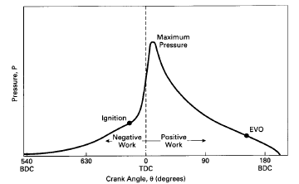

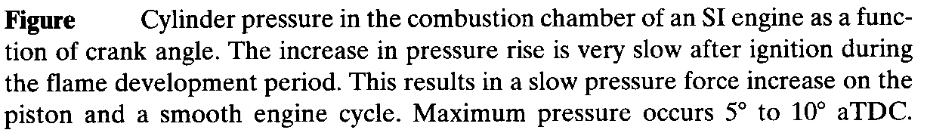
time, pressure in theexpansion stroke. The final 5% (some sources use 10%) of the air-fuel

mass which burns is classified as flame termination. During this time, pressure quickly decreases and combustion stops. Inan SI engine, combustion ideally consists of an exothermic subsonic flame progressing through a premixed homogeneous air-fuel mixture. The spread of the flame front is greatly increased by induced turbulence, swirl, and squish within the cylinder. The right combination of fuel and operating characteristics is such that knock is avoided or almost avoided.

Types of combustion:

1. Normal Combustion.

2. Abnormal Combustion.

Normal Combustion:

Normal combustion rarely occurs in a real engine without some trace of autoignition appearing. After ignition, the flame front travels across the combustionchamber. The gas a heat of the flame front called the"end gas ". The end gas receivesheat due to compression by expanding gases and by radiation from the advancingflame front, therefore, its temperature and density increases. If the temperatureexceeds the self – ignition

COMPILED BY: SP.ARUNKUMAR, AP (SR.GR)/MECH

SRI RAMAKRISHNA INSTITUTE OF TECHNOLOGY, PACHAPALAYAM, COIMBATORE-10. 10 out of 99

ME 2041 - ADVANCED I.C. ENGINES

temperature and the un-burnt gas remains at or above thistemperature for a period of time equal to/or greaterthe delay period, spontaneous ignition(or auto ignition) will occurs at variouslocations. Shortly after words an audible sound called knock appears. If the end gas does not reachits self-ignition temperature, thecombustion will be normal.

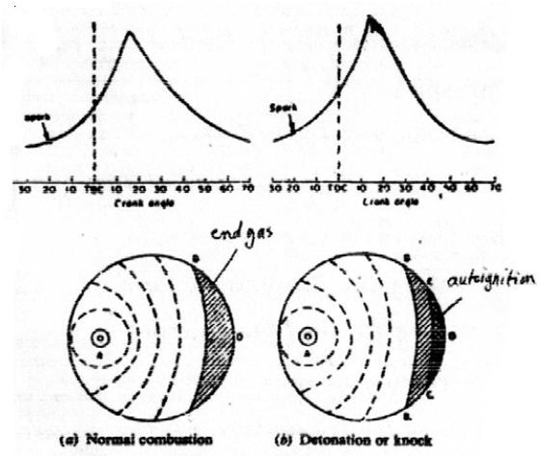

Abnormal Combustion:

In Internal combustion engines, abnormal combustion is a significant phenomenon associated with the combustion processes on which the life and performance of the engine depends. The two important abnormal combustion phenomenons are 1. KNOCK and 2.SURFACE IGNITION. These abnormal combustion phenomenons are of concern because (1) when severe, they can cause major engine damage; and (2) even if not severe, they are regarded as an objectionable source of noise by the engine.

COMPILED BY: SP.ARUNKUMAR, AP (SR.GR)/MECH

SRI RAMAKRISHNA INSTITUTE OF TECHNOLOGY, PACHAPALAYAM, COIMBATORE-10. 11 out of 99

ME 2041 - ADVANCED I.C. ENGINES

KNOCK

Knock is the most important abnormal combustion phenomenon. It important

because it puts a limit on the compression ratio at which an engine can be operated ,which in turn controls the efficiency and to some extent power output. It got the name “Knock” because of the noise that results from the auto ignition of a portion of fuel air mixture ahead of the advancing flame. As the spark is ignited there is a formation of flame front and it starts propagating. As the flame propagates across the combustion chamber, speed of flame front is about 15-30 m/s ; the unburned charge ahead of the flame called the END GAS is compressed, raising its pressure, temperature and density. In case of abnormal combustion the end gas fuel air mixture undergo fast chemical reactions, which results in auto ignition prior to normal combustion (i.e. theflame front reaching it). During auto ignition a large portion of end gas releases its chemical energy rapidly and spontaneously at a rate 5 to 25 times as in case of normal combustion. This spontaneous ignition of the End gas raises the pressure very rapidly and causes high frequency oscillations inside the cylinder resulting in a high pitched metallic noise characterized as KNOCK. During this knocking phenomenon pressure waves of very large amplitudes propagate across the combustion chamber and very high local pressures are produced which are as high as 150 to 200 bars. Local 5% ofthe total charge is sufficient to produce a very violent serve knock. The velocity reached during knock is of the order of 300 to 1000 m\s.
Basically knock depends on the outcome of shorter of two different processes (i.e. Least time taken by one of the two processes) they are:

1. The advancing flame front grabbing all the fuel air mixture.

2. The pre combustion reaction in the unburned end gas. The time taken in this

preparative phase of auto ignition (i.e. pre combustion reaction) is called “Ignition delay". Knock will not occur if the ignition delay is so long that the flame front consumes all the end gas and auto ignition takes place i.e. normal combustion occurs. Knock will occur if the pre combustion reaction produce auto ignition before the flame front arrives. Auto ignition when occurs repeatedly, the phenomenon is called “Spark Knock" .Spark knock is controllable by spark advance: advancing the spark increases the knock intensity and retarding the spark decreases the knock.

COMPILED BY: SP.ARUNKUMAR, AP (SR.GR)/MECH

SRI RAMAKRISHNA INSTITUTE OF TECHNOLOGY, PACHAPALAYAM, COIMBATORE-10. 12 out of 99

ME 2041 - ADVANCED I.C. ENGINES

CHARACTERISTICS OF KNOCK :

Knock in S.I. engine generally occurs at the end of combustion process during

which the end gas charge is trapped between the advancing flame front and the

engine. Cylinder periphery.

Knock primary occurs under wide open throttle operating condition thus it is a
direct constrain on engine performance.

It also constrains engine efficiency, as it limits the temp and pressure of the end gas

and thus limits the compression ratio of the engine

The impact of knock depends on its intensity and duration. If knock is short duration

usually called "Acceleration Knock" it is unlikely to cause damage. But “Constant

Speed Knock" however can lead to engine damage.

SURFACE IGNITION

The other important abnormal combustion phenomenon is surface ignition. Surface ignition is ignition of fuel air charge by overheated valves or spark plugs, by glowing combustion chamber deposits, or by any other hot spot in the engine combustion chamber. It is the initiation of flame front by a hot surface other than the spark plug. Mostly surface ignition is due to carbon deposits.

Surface ignition may occur before the spark plug ignites the charge (pre ignition) or after normal ignition (post ignition). It may produce a single flame or multiple flames. Uncontrolled combustion is most evident and the results are most severe in case of pre ignition. Surface ignition may also causeknock . As due surface ignition there is a rapid and high rise of pressure and temperature than in case of normal combustion

COMPILED BY: SP.ARUNKUMAR, AP (SR.GR)/MECH

SRI RAMAKRISHNA INSTITUTE OF TECHNOLOGY, PACHAPALAYAM, COIMBATORE-10. 13 out of 99

ME 2041 - ADVANCED I.C. ENGINES

because the flame either starts propagating sooner, or it does from more than one sources, which likely results in Knocking.

Knocking is also an outcome of Surface ignition. To identify whether surface

ignition causes knock or not, the term "knocking surface ignition" and "non-knocking s01urface ignition" are used. Knocking surface ignition usually occurs due to pre ignition caused by glowing combustion chamber deposits and can't be controlled by retarding the spark timing since knock is not due to spark ignited flame. While the non-knocking surface ignition occurs late in the operating cycle.

Different surface ignition phenomenon is wild ping, run on, run away, rumble, etc.

Knocking surface ignition may give rise to "Wild Ping” and non-knocking surface ignition to "Rumble". While both knocking and non-knocking surface ignition may give rise to "Run-On" and "Run-Away".

Wild Ping

Wild ping is a variation of knocking surface ignition, which produces sharp

cracking noise in bursts. Probably it results from early ignition of the fuel air mixture in the combustion chamber by glowing loose deposit particles. It disappears when the particles are exhausted and reappears when fresh particles break loose from the combustion chamber surfaces.

Rumble

Rumble is a relatively stable low frequency noise (600-1200 Hz) phenomenon associated with deposit -caused surface ignition in high compression ratio engines. The pressure rises rapidly to a high value and resulting in engine vibration. Rumble and knock can occur together.

COMPILED BY: SP.ARUNKUMAR, AP (SR.GR)/MECH

SRI RAMAKRISHNA INSTITUTE OF TECHNOLOGY, PACHAPALAYAM, COIMBATORE-10. 14 out of 99

ME 2041 - ADVANCED I.C. ENGINES

Run-on

Run-on occurs when the fuel air mixture within the cylinder continues to ignite when the ignition system is switched off. During run-on the engine usually produces knock like noises. It is probably caused by the compression ignition of fuel air mixture (assisted by surface ignition).

Run-away

Run-away is surface ignition which occurs earlier and earlier in the cycle. It is usually caused by overheated sparkplugs or valves. It the most destructive type of surface ignitions which may lead to disastrous results—seizure or melting of piston or the engine catching fire. It can lead to serious overheating and structural damage to the engine.

PRE-IGNITION

As discussed earlier, pre ignition is the phenomenon of surface ignition before the

passage of spark. The usual cause is an overheated spot, whichmay occur at spark plugs, combustion chamber deposits, or exhaust valves. Mostly it is due to spark plug. Exhaust valve usually run hot and sometimes when there is increase in heat load for these valves there will be an increase in the temperature and may cause pre ignition. Heat transfer principles indicate that the surface of the deposits is hotter than the metal surface to which the deposits are attached. Hence, sufficient deposits result in hot enough surfaces to cause pre ignition.

Pre ignitionis potentially the most damaging surface ignition phenomenon. The effect of pre ignition is same as very advanced ignition timing. Any process that advances the start of combustion that gives maximum torque will cause higher heat rejection because of the increased burned gas pressures and temperatures (due to the negative work done during the compression stroke). Higher heat rejection causes higher temperature components thus the pre ignition damage is largely thermal which is evidenced by the fusion of spark plugs, piston and destruction of piston rings.

COMPILED BY: SP.ARUNKUMAR, AP (SR.GR)/MECH

SRI RAMAKRISHNA INSTITUTE OF TECHNOLOGY, PACHAPALAYAM, COIMBATORE-10. 15 out of 99

ME 2041 - ADVANCED I.C. ENGINES

Factors affecting knock

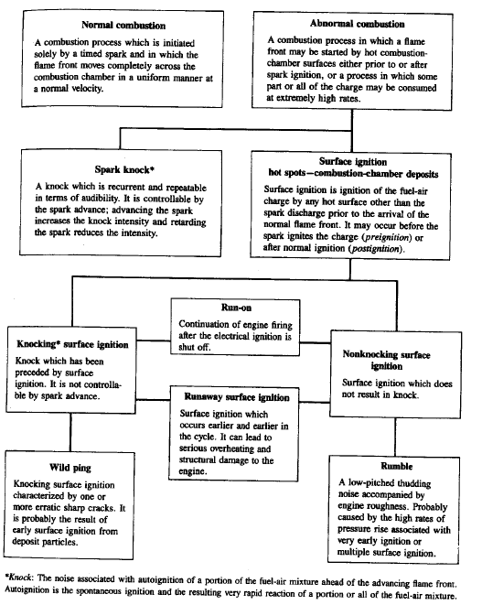
COMPILED BY: SP.ARUNKUMAR, AP (SR.GR)/MECH

SRI RAMAKRISHNA INSTITUTE OF TECHNOLOGY, PACHAPALAYAM, COIMBATORE-10. 16 out of 99

ME 2041 - ADVANCED I.C. ENGINES

What is Knocking?

Knock is the name given to the noise which is transmitted through the engine structure when essentially spontaneous ignition of a portion of the end-gas-the fuel, air, residual gas, mixture ahead of the propagating flame occurs. When this abnormal combustion process takes place, there is an extremely rapid release of much of the chemical energy in the end-gas, causing very high local pressures and the propagation of pressure waves of substantial amplitude across the combustion chamber.
Effect of Knock:

- Knock has the following effects on engine operation.
- Noise and Roughness.
- Mechanical damage: increase in engine wear, cylinder head and valves may be pitted.
- Carbon deposits.
- Increase in heat transfer.
- Decrease in power output and efficiency.
- Pre-ignition: combustion Occurs before the spark.

Effect of engine variables on Knock:

To prevent Knock in the S.I. engine the end gas should have:
A- Low temperature.
B- Low density.

C- Long ignition delay.

D- Non- reactive combustion.

When the engine conditions are changed, the effect of the change may be reflected by more than one of the above variables.

A- Temperature factors:

The temperature of the unburned mixture is increased by the following factors:
1. Raising the compression ratio.
2. Supercharging.

3. Raising the inlet temperature.
4. Raising the coolant temperature.

COMPILED BY: SP.ARUNKUMAR, AP (SR.GR)/MECH

SRI RAMAKRISHNA INSTITUTE OF TECHNOLOGY, PACHAPALAYAM, COIMBATORE-10. 17 out of 99

ME 2041 - ADVANCED I.C. ENGINES

5. Increasing load.

6. Advancing the spark.

- Raising the temperature of the cylinder and combustion chamber walls.
B- Density factors:
Increasing density by any of the following methods will increase the possibility of Knock:
1. Increasing load.

2. Increasing compression ratio.
3. Supercharging.
4. Advancing the spark
C- Time factors:
Increasing the time of exposure of the unburned mixture to auto-ignitions by any of the following factors will increase tendency to knock:

1. Increasing the distance of the flame travel. 2. Decreasing the turbulence of mixture.
3. Decreasing the speed of the engine.
D- Composition:
The probability of Knock in S.I. engines is decreased by:
1. Increasing the octane rating of the fuel.
2. Either rich or lean mixtures.
3. Stratifying the mixture.
4. Increasing the humidity of the entering air.

Combustion chambers

There are basically four types of combustion chambers they are,

a. Bathtub and wedge. b. Blow in piston.
c. Four valve pent proof. d. Hemispherical.

COMPILED BY: SP.ARUNKUMAR, AP (SR.GR)/MECH

SRI RAMAKRISHNA INSTITUTE OF TECHNOLOGY, PACHAPALAYAM, COIMBATORE-10. 18 out of 99

ME 2041 - ADVANCED I.C. ENGINES

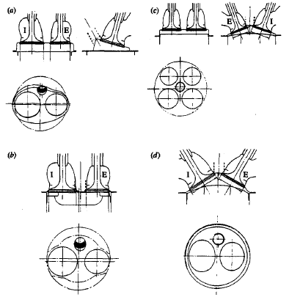

Types of Combustion chambers

The major combustion chamber design objectives which relate to engine performance and emissions are: (1) a fast combustion process, with low cycle-bycyclevariability, over the full engine operating range; (2) a high volumetric efficiencyat wide-open throttle; (3) minimum heat loss to the combustion chamberwalls; (4) a low fuel octane requirement.

Many methods for producing a "fast bum" have been proposed. Theseinclude ways of making the combustion chamber shape more compact, movingthe spark plug to a more central location within the chamber, using two plugs,and increasing in-cylinder gas motion by creating swirl during the inductionprocess or during the latter stages of compression.A faster combustion process relative to more moderate bum rate enginesdoes result in a direct engine efficiency gain, other factors being equal. The magnitudeof this direct gain is relatively modest. Experimental studies of the effect ofan increase in burn rate from moderate to fast at constant engine load, speed, and mixture composition show that this effect is a few percent at most.

COMPILED BY: SP.ARUNKUMAR, AP (SR.GR)/MECH

SRI RAMAKRISHNA INSTITUTE OF TECHNOLOGY, PACHAPALAYAM, COIMBATORE-10. 19 out of 99

ME 2041 - ADVANCED I.C. ENGINES

23 Computer simulations of the engine operating cycle confirm these experimental observations:while a decrease in total burn duration from 100 to 60' (slow to moderate burn) does result in a 4 percent decrease in bsfc, a decrease in bumduration from 60 to 20" gives only a further 1.5 percent bsfcdecrea~e.~of greater importance is the fact that the faster bum process is more robustand results in the engine being able to operate satisfactorily with much more EGR, or much leaner, without a large deterioration in combustion quality. Faster burning chamber designs exhibit much less cycle-by-cycle variability. This abilityto operate with greater dilution at part load while maintaining a short burnduration and low cycle-by-cycle variability, permits much greater control of NO,within the engine with 20 or more percent EGR without any substantial increasein HC emissions (see Fig. 11-29), or permits very lean operation. In both cases theefficiency gain relative to moderate burn rate engines, which must operate with lessdilution, is sizeable.24High volumetric efficiency is required to obtain the highest possible powerdensity. The shape of the cylinder head affects the size of valves that can beincorporated into the design. Effective valve open area, which depends on valvediameter and lift, directly affects volumetric efficiency. Swirl is used in manymodern chamber designs to speed up the burning process and achieve greatercombustion stability. Induction-generated swirl appears to be a particularlystable in-cylinder flow.
Heat transfer to the combustion chamber walls has significant impact onengine efficiency. It is affected by cylinder head and piston crown surface area, bythe magnitude of in-cylinder gas velocities during combustion and expansion, bythe gas temperatures and the wall temperatures. The heat-transfer implications ofa combustion chamber should be included in the design process.Knock effectively limits the maximum compression ratio that can be used in any combustion chamber; it therefore has a direct impact on efficiency. Knockis affected by all the factors discussed above. It is the hardest of all the constraintsto incorporate into the design process because of its obvious complexity.Knowledge of the fundamentals of spark-ignition engine combustion, incylindergas motion, and heat transfer has developed to the point where a rationalprocedure for evaluating these factors for optimum combustion chamberdevelopment and design can be defined. The next two sections develop such aprocedure burning chamber designs exhibit much less cycle-by-cycle variability. This abilityto operate with greater dilution at part load while maintaining a short burnduration and low cycle-by-cycle variability, permits much greater control of NO, within the engine with 20 or more percent EGR without any substantial increase in HC

COMPILED BY: SP.ARUNKUMAR, AP (SR.GR)/MECH

SRI RAMAKRISHNA INSTITUTE OF TECHNOLOGY, PACHAPALAYAM, COIMBATORE-10. 20 out of 99

ME 2041 - ADVANCED I.C. ENGINES

emissions fig), or permits very lean operation. In both cases theefficiency gain relative to moderate burn rate engines, which must operate with lessdilution, is sizeable. High volumetric efficiency is required to obtain the highest possible powerdensity. The shape of the cylinder head affects the size of valves that can beincorporated into the design. Effective valve open area, which depends on valvediameter and lift, directly affects volumetric efficiency. Swirl is used in many modern chamber designs to speed up the burning process and achieve greater combustion stability. Induction-generated swirl appears to be a particularlystable in-cylinder flow. Swirl results in higher turbulence inside the chamberduring combustion, thus increasing the rate of flame development and propagation.Generating swirl during the intake process decreases volumetric efficiency.Heat transfer to the combustion chamber walls has a significant impact onengine efficiency. It is affected by cylinder head and piston crown surface area, bythe magnitude of in-cylinder gas velocities during combustion and expansion, bythe gas temperatures and the wall temperatures. The heat-transfer implications ofa combustion chamber should be included in the design process.Knock effectively limits the maximum compression ratio that can be usedin any combustion chamber; it therefore has a direct impact on efficiency. Knockis affected by all the factors discussed above. It is the hardest of all the constraintsto incorporate into the design process because of its obvious complexity.
Knowledge of the fundamentals of spark-ignition engine combustion, incylindergas motion, and heat transfer has developed to the point where a rationalprocedure for evaluating these factors for optimum combustion chamberdevelopment and design can be defined. The next two sections develop such aprocedure burning chamber designs exhibit much less cycle-by-cycle variability. This abilityto operate with greater dilution at part load while maintaining a short burnduration and low cycle-by-cycle variability, permits much greater control of NO, Within the engine with 20 or more percent EGR without any substantial increase in HC emissions, or permits very lean operation. In both cases theefficiency gain relative to moderate burn rate engines, which must operate with lessdilution, is sizeable. High volumetric efficiency is required to obtain the highest possible powerdensity. The shape of the cylinder head affects the size of valves that can beincorporated into the design. Effective valve open area, which depends on valvediameter and lift, directly affects volumetric efficiency. Swirl is used in manymodern chamber designs to speed up the burning process and achieve greater combustion stability. Induction-generated swirl appears to be a particularly stable in-cylinder flow.

COMPILED BY: SP.ARUNKUMAR, AP (SR.GR)/MECH

SRI RAMAKRISHNA INSTITUTE OF TECHNOLOGY, PACHAPALAYAM, COIMBATORE-10. 21 out of 99

ME 2041 - ADVANCED I.C. ENGINES

Swirl results in higher turbulence inside the chamberduring combustion, thus increasing the rate of flame development and propagation. Generating swirl during the intake process decreases volumetric efficiency.
Heat transfer to the combustion chamber walls has a significant impact onengine efficiency. It is affected by cylinder head and piston crown surface area, bythe magnitude of in-cylinder gas velocities during combustion and expansion, bythe gas temperatures and the wall temperatures. The heat-transfer implications ofa combustion chamber should be included in the design process.
Knock effectively limits the maximum compression ratio that can be usedin any combustion chamber; it therefore has a direct impact on efficiency. Knockis affected by all the factors discussed above. It is the hardest of all the constraintsto incorporate into the design process because of its obvious complexity.Knowledge of the fundamentals of spark-ignition engine combustion, in cylindergas motion, and heat transfer has developed to the point where a rationalprocedure for evaluating these factors for optimum combustion chamberdevelopment and design can be defined. The next two sections develop such aprocedure burning chamber designs exhibit much less cycle-by-cycle variability. This abilityto operate with greater dilution at part load while maintaining a short burnduration and low cycle-by-cycle variability, permits much greater control of NO,within the engine with 20 or more percent EGR without any substantial increasein HC emissions (see Fig. 11-29), or permits very lean operation. In both cases theefficiency gain relative to moderate burn rate engines, which must operate with lessdilution, is sizeable. High volumetric efficiency is required to obtain the highest possible powerdensity. The shape of the cylinder head affects the size of valves that can beincorporated into the design. Effective valve open area, which depends on valvediameter and lift, directly affects volumetric efficiency. Swirl is used in manymodern chamber designs to speed up the burning process and achieve greatercombustion stability. Induction-generated swirl appears to be a particularlystable in-cylinder flow. Swirl results in higher turbulence inside the chamberduring combustion, thus increasing the rate of flame development and propagation.Generating swirl during the intake process decreases volumetric efficiency.Heat transfer to the combustion chamber walls has a significant impact onengine efficiency. It is affected by cylinder head and piston crown surface area, bythe magnitude of in-cylinder gas velocities during combustion and expansion, by the gas temperatures and the wall temperatures.

COMPILED BY: SP.ARUNKUMAR, AP (SR.GR)/MECH

SRI RAMAKRISHNA INSTITUTE OF TECHNOLOGY, PACHAPALAYAM, COIMBATORE-10. 22 out of 99

ME 2041 - ADVANCED I.C. ENGINES

The heat-transfer implications of a combustion chamber should be included in the design process. Knock effectively limits the maximum compression ratio that can be used in any combustion chamber; it therefore has a direct impact on efficiency. Knock is affected by all the factors discussed above. It is the hardest of all the constraints to incorporate into the design process because of its obvious complexity. Knowledge of the fundamentals of spark-ignition engine combustion, incylinder gas motion, and heat transfer has developed to the point where a rationalprocedure for evaluating these factors for optimum combustion chamberdevelopment and design can be defined. The next two sections develop such aprocedure.

Thermodynamic analysis of SI engine combustion process

Burned and Unburned Mixture States

The gas pressure, temperature, and density change as a result of changes in volume due to piston motion. During combustion, the cylinder pressure increases due to the release of the fuel'schemical energy. As each element of fuel-air mixture bums, its density decreasesby about a factor of four. This combustion-produced gas expansion compressesthe unburned mixture ahead of the flame and displaces it toward the combustionchamber walls. The combustion-produced gas expansion also compresses thoseparts of the charge which have already burned, and displaces them back towardthe spark plug. During the combustion process, the unburned gas elements moveaway from the spark plug; following combustion, individual gas elements moveback toward the spark plug. Further, elements of the unburned mixture whichburn at different times have different pressures and temperatures just prior to combustion, and therefore end up at different states after combustion. The thermodynamic state and composition of the burned gas is, therefore, non-uniform. A first law analysis of the spark-ignition engine combustion process enables us toquantify these gas states.Work transfer occurs between the cylinder gases andthe piston (to the gas before TC; to the piston after TC). Heat transfer occurs tothe chamber walls, primarily from the burned gases. At the temperatures andpressures typical of spark-ignition engines it is a reasonable approximation toassume that the volume of the reaction zone where combustion is actuallyoccurring is a negligible fraction of the chamber volume even though the thicknessof-the turbulent flame may not be negligible compared with the chamberdimensions (see Sec. 9.3.2). With normal engine operation, at any point in time orcrank angle, the pressure throughout the cylinder is close to uniform.

COMPILED BY: SP.ARUNKUMAR, AP (SR.GR)/MECH

SRI RAMAKRISHNA INSTITUTE OF TECHNOLOGY, PACHAPALAYAM, COIMBATORE-10. 23 out of 99

ME 2041 - ADVANCED I.C. ENGINES

The conditions in the burned and unburned gas are then determined by conservation of mass:
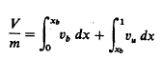

and conservation of energy:

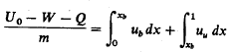

where V is the cylinder volume, m is the mass of the cylinder contents, o is thespecific volume, xbis the mass fraction burned, Uois the internal energy of thecylinder contents at some reference point 80, u is the specific internal energy, Wis the work done on the piston, and Q is the heat transfer to the walls. Thesubscripts u and b denote unburned and burned gas properties, respectively. Thework and heat transfers are

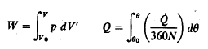

where 0 is the instantaneous heat-transfer rate to the chamber walls.To proceed further, models for the thermodynamic properties of the burnedand unburned gases are required. Several categories of models are described inChap. 4. Accurate calculations of the state of the cylinder gases require an equilibriummodel (or good approximation to it) for the burned gas and an ideal gasmixture model (of frozen composition) for the unburned gas.However, useful illustrative results can be obtained by assuming that the burnedand unburned gases are different ideal gases, each with constant specific heat.

COMPILED BY: SP.ARUNKUMAR, AP (SR.GR)/MECH

SRI RAMAKRISHNA INSTITUTE OF TECHNOLOGY, PACHAPALAYAM, COIMBATORE-10. 24 out of 99

ME 2041 - ADVANCED I.C. ENGINES

UNIT-II

COMPRESSION IGNITION ENGINES

Stages of combustion:

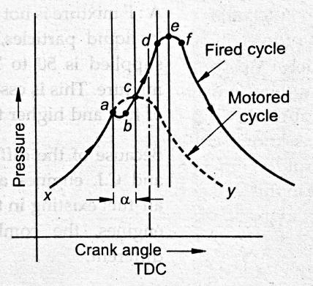
Stages of combustion

Stages of combustion can be divided into four stages namely,

1. Pre-flame combustion

2. Uncontrolled combustion 3. Controlled combustion and 4. After burning.
Pre flame combustion:

In actual engine cycle, the fuel injection starts at the point ‘a’ shown in fig. As soon as the fuel jet is known into a fine spray, the fuel starts absorbing heat from the surrounding high temperature air and vaporization of fuel starts. But in the absence of flame, therefore it is known as pre-flame reaction. At the beginning of pre-flame combustion, the energy release rate is very less than rate of heat absorption by the fuel because the amount of fuel vapour is small. As a result, the pressure in the cylinder decreases with the progressive fuel

COMPILED BY: SP.ARUNKUMAR, AP (SR.GR)/MECH

SRI RAMAKRISHNA INSTITUTE OF TECHNOLOGY, PACHAPALAYAM, COIMBATORE-10. 25 out of 99

ME 2041 - ADVANCED I.C. ENGINES

vaporization. This decrease in pressure attains a maximum value when the energy release due to pre-flame reaction is equal to the rate of heat absorption by the fuel. This process of fuel vaporization and subsequent decrease in pressure in the cylinder is shown on fig by paths ‘ab’.
As the energy release rate due to pre-flame reaction is more than the rate of heat

absorption, the pressure inside the cylinder starts increasing. This rising pressure intersects the pressure curve without the fuel injection at the point ‘c’. At point ‘c’, the pressure drop caused by the fuel vaporization is completely recovered by the energy released due to preflame combustion. The pressure inside the cylinder after the point ‘c’ rapidly increases as the ignition takes place somewhere around the point ‘c’ and flame appears. The actual flame (actual combustion) starts at the point ‘c’ where as the fuel injection starts at point ‘a’. The time required to start the actual combustion of after starting the fuel injection is known as “delay period” and the crank angle required for this is known as “delay period angle” and it is shown in the fig by an angle α.

Uncontrolled Combustion:

The time and place where ignition will stop is not fixed by anything in compression ignition engine as in SI engines.
The air fuel mixture in the combustion chamber before starting the combustion is very heterogeneous and the concentration of the fuel may vary from 0 to 100%. The first ignition (flame) generally occurs in the region of chemically correct A:F mixture because it requires minimum reaction time. Once the ignition takes place, the flame formed propagates through the mixture of air and vaporized fuel and ignites the adjacent part of the charge or it may initiate the auto ignition in the part of A:F mixture away from the flame front by transferring the heat by radiation.
A considerable amount of fuel is accumulated in the combustion chamber during the relay period (time between the start of injection of fuel and start of ignition of fuel). This accumulated fuel burns very rapidly causing a steep raise in the cylinder pressure. The rate of pressure raise increases with the increase in delay period because of the amount of fuel taking part in this combustion increase with an increasing delay period. This phase of combustion causing rapid pressure raise in the cylinder is known as “period of uncontrolled combustion”.

COMPILED BY: SP.ARUNKUMAR, AP (SR.GR)/MECH

SRI RAMAKRISHNA INSTITUTE OF TECHNOLOGY, PACHAPALAYAM, COIMBATORE-10. 26 out of 99

ME 2041 - ADVANCED I.C. ENGINES

Controlled combustion:

All the accumulated fuel during the delay period generally burns during the period of controlled combustion. The fuel injected after this (after point d) burns at the same rate at which it is injected because, the vaporisation of fuel, mixing with the air and burning takes place almost instantaneously as the fuel leaves the nozzle. This is because, the temperature and pressure inside the cylinder are sufficiently high and sufficient turbulence is created due to precious burning, thus the delay period for the fuel injected after point “d” is almost zero. This period of combustion is known as “controlled combustion” because the rate of burning can be controlled by controlling the rate of injection. This is confirmed until the supply of fuel ceases. This process is shown by the path “de” on the fig.

After burning:

The thermal decomposition of the part of fuel takes place during uncontrolled and controlled combustion. The decomposed fuel molecules contain enough number of hydrocarbons and carbon particles which has lower reaction rates. Some carbon and hydro carbon, decomposed from fuel are left in the combustion product because the rate of decomposition during uncontrolled and controlled combustion is more than the rate of reaction of these molecules during that period. These unburned hydrocarbons and carbon generally burn after stopping the fuel injection during the expansion stroke. This process of combustion of decomposed carbon atoms is known as “after burning”.

Abnormal Combustion

Delay period:

Delay period is the time interval (measured in milliseconds) between the commencement of fuel injection and the beginning of ignition and combustion. The start of combustion is indicated by the deviation of point of the pressure curve above the normal compression pressure. In practice, this actual time is as low as 0.006 seconds. The delay period consists of the following:
1. Physical delay period. 2. Chemical delay period.

COMPILED BY: SP.ARUNKUMAR, AP (SR.GR)/MECH

SRI RAMAKRISHNA INSTITUTE OF TECHNOLOGY, PACHAPALAYAM, COIMBATORE-10. 27 out of 99

ME 2041 - ADVANCED I.C. ENGINES

Physical delay period:

Physical delay period or the mixing period is the time elapses between the beginning of fuel injection and the beginning of pre flame reactions. During this period, heating, and vaporization of the fuel drop and diffusion of air into the vapour layer takes place. This results in the formation of suitable mixture of fuel vapour and air ready for chemical reaction. Chemical delay period:
Chemical delay period or integration period is the time that elapses between the beginning of chemical and beginning of ignition. During this period, the fuel vapour is being oxidized at an ever increasing rate until ignition occurs. In other words, this is the period taken up by the chemical reactions to attain the point of burning or self-ignition. In addition to the above, the delay period is also influenced by the degree of atomization i.e.disintegration of fuel jet injected and characteristics of combustion chamber. The delay is the more or less constant in time units. In high speed diesel engines, ignition delay is in the order of 0.0012 to 0.0018 seconds.

Factors influencing delay period:

1. Characteristics of fuel (self-ignition temperature, volatility and viscosity). 2. Temperature and pressure of compressed air.
3. Degree of atomization of injected fuel.

4. Air motion / turbulence present in the combustion space. 5. Engine speed.
6. Injection timing.

7. Characteristics of the combustion chamber.

Factors affecting knock

Knocking is violet gas vibration and audible sound produced by extreme pressure

differentials leading to the very rapid rise during the early part of uncontrolled second phase of combustion.

In C.I. engines the injection process takes place over a definite interval of time.

Consequently, as the first few droplets injected are passing through the ignition lag period, additional droplets are being injected into the chamber. If the ignition delay is longer, the

COMPILED BY: SP.ARUNKUMAR, AP (SR.GR)/MECH

SRI RAMAKRISHNA INSTITUTE OF TECHNOLOGY, PACHAPALAYAM, COIMBATORE-10. 28 out of 99

ME 2041 - ADVANCED I.C. ENGINES

actual burning of the first few droplets is delayed and a greater quantity of fuel droplets gets accumulated in the chamber. When the actual burning commences, the additional fuel can cause too rapid a rate of pressure rise, as shown on pressure crank angle diagram above, resulting in Jamming of forces against the piston (as if struck by a hammer) and rough engine operation. If the ignition delay is quite long, so much fuel can accumulate that the rate of pressure rise is almost instantaneous. Such, a situation produces extreme pressure differentials and violent gas vibration known as knocking (diesel knock), and is evidenced by audible knock. The phenomenon is similar to that in the SI engine. However, in SI Engine knocking occurs near the end of combustion whereas in CI engine, knocking thatoccurs near the beginning of combustion.

Delay period is directly related to Knocking in CI engine. An extensive delay periodcan be due to following factors:

• A low compression ratio permitting only a marginal self -ignition temperature to be reached.
• A low combustion pressure due to worn out piston, rings and bad valves • Low cetane number of fuel
• Poorly atomized fuel spray preventing early combustion

• Coarse droplet formation due to malfunctioning of injector parts like spring • Low intake temperature and pressure of air

FACTORS AFFECTING KNOCKING

Injection timing

At normal operating conditions min ignition delay (ID) occurs with start of injection at 10 to 15 OCA BTDC.
Cylinder temperature and pressure drops if injection is earlier or later (high at first but decrease as delay proceeds).
Injection quantity (load)

Reducing engine load changes AFR, cools down the engine, reduces wall temperatures, reduces residual gas temperatures and increases ID
Droplet size, injection velocity and rate

Ignition quality within practical limits does not have significant effect on ID

COMPILED BY: SP.ARUNKUMAR, AP (SR.GR)/MECH

SRI RAMAKRISHNA INSTITUTE OF TECHNOLOGY, PACHAPALAYAM, COIMBATORE-10. 29 out of 99

ME 2041 - ADVANCED I.C. ENGINES

including in injection produces only modest decreasing in ID Injector nozzle diameter effects droplet size but has no significant effect on ID.
Intake air temperature and pressure
Reducing intake air T and p increases ID.
Strong dependence of ID on charge temperature below 1000 K – above this value effect of intake air conditions is not significant.
Engine speed

Increase in engine speed increases the air motion and turbulence, reduces ID time slightly (in ms), in terms of CA degrees ID increases almost linearly.A change in engine speed, changes “temp~time” and “pressure~time” relationships.
Combustion chamber design

Spray impingement on the walls effect fuel evaporation and ID.

Increase in compression ratio, increases pressure and temperature and reduces ID.

Reducing stroke volume, inc surface area to volume ratio, increases engine cooling and increases ID.
Swirl rate

Change evaporating rate and air-fuel mixing - under normal operating conditions the effect is small.
At start-up (low engine speed and temperature) more important, high rate of evaporation and mixing is obtained by swirl.
Oxygen concentration

Residual gases reduce O2 concentration and reducing oxygen concentration increases ID.

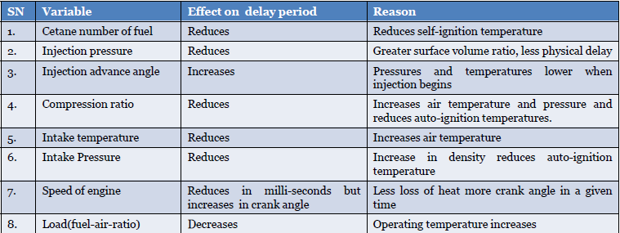

COMPILED BY: SP.ARUNKUMAR, AP (SR.GR)/MECH

SRI RAMAKRISHNA INSTITUTE OF TECHNOLOGY, PACHAPALAYAM, COIMBATORE-10. 30 out of 99

ME 2041 - ADVANCED I.C. ENGINES

METHODS OF CONTROLING DIESEL KNOCK

We have discussed the factors which are responsible for the detonation in the previous

sections. If these factors are controlled, then the detonation can be avoided.

• Using a better fuel. Higher CN fuel has lower delay period and reduces knocking tendency.
• Controlling the Rate of Fuel Supply. By injecting less fuel in the beginning andthen more fuel amount in the combustion chamber detonation can be controlled to a certain extent. Cam shape of suitable profile can be designed for this purpose.
• Knock reducing fuel injector: This type of injector avoid the sudden increase in pressure inside the combustion chamber because of accumulated fuel. This can be done by arranging the injector so that only small amount of fuel is injected first. This can be achieved by using two or more injectors arranging in out of phase.
• By using Ignition accelerators : C N number can be increased by addingchemical called dopes. The two chemical dopes are used are ethyl-nitrate andamyle –nitrate in concentration of 8.8 gm/Litre and 7.7 gm/Litre. But these twoincrease the NOx emissions.
• Increasing Swirl : Knocking can be greatly reduced by increasing swirl ( orreducing turbulence). Swirl helps in knock free combustion.

Direct injection systems

Diesel injection engines are divided into two categories and they are

a. Direct – injection engines. b. Indirect – injection engines.

Direct – injection engines have single open combustion chamber into which fuel is injected

directly.

COMPILED BY: SP.ARUNKUMAR, AP (SR.GR)/MECH

SRI RAMAKRISHNA INSTITUTE OF TECHNOLOGY, PACHAPALAYAM, COIMBATORE-10. 31 out of 99

ME 2041 - ADVANCED I.C. ENGINES

Indirect – injection engines have chambers divided into two regions and the fuel is injected into the “prechamber” which is connected to main chamber via nozzle, one or more orifices. IDI engines are only used in small engine sizes.

Direct – Injection systems:

In largest size engines, where mixing rate requirement are lease stringent, quiescent direct – injection systems of the type are used. The momentum and energy of the injected fuel jets are sufficient to achieve adequate fuel distribution and rates of mixing with the air. Additional organized air motion is not required. The combustion chamber shape is usually a shallow bhowl in the crown of the piston, and a central multihole injector is used.
As engine size decreases, increasing amounts of air swirl are used to achieve faster fuel – air mixing rates. Air swirl is generated by suitable design of the inlet port. The swirl rate can be increased as the piston approached TC by forcing the air oward the cylinder axis, into a bowl-in-piston type of combustion chamber.

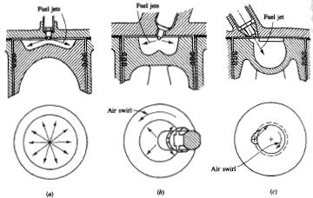
Fig b and c shows the two types of DI engine with swirl in combustion use. Fig b shows a DI engine with swirl, with centrally located multi hole injector nozzle. Here the design is to hold the amount of liquid fuel which impinges nozzle. Here the design goal is to hold the amount of liquid fuel which impinges on the piston cu[ walls to a minimum. Fig c shows the M.A.N. “M system” with its single-hole fuel injection nozzle, oriented so that most of the fuel is deposited on the piston bowl walls. These two types of designs are used in

COMPILED BY: SP.ARUNKUMAR, AP (SR.GR)/MECH

SRI RAMAKRISHNA INSTITUTE OF TECHNOLOGY, PACHAPALAYAM, COIMBATORE-10. 32 out of 99

ME 2041 - ADVANCED I.C. ENGINES

medium-size (10 to 15cm bore) diesels and with increase swirl, in small size (8 to 10cm bore) diesels.

Indirect injection systems

Inlet generated air swirl, despite amplification in the piston cup, has not provided sufficiently high fuel-air mixing rates for small high-speed diesels such as those used in automobiles. Indirect-injection or divided-chamber engine systems have been used instead, where the vigorous charge motion required during fuel injection is generated during the compression stroke. Two broad classes of IDI system can be defined (1) swirl chamber systems and (2) prechamber systems, as illustrated in fig a and b, respectively. During compression, air is forced from the main chamber above the piston into the auxiliary chamber, through the nozzle or orifice (or set of orifices). Thus, toward the end of the compression, a vigorous flow in the auxiliary chamber is set up: in swirl chamber systems the connecting passage and chamber are shaped so that this flow within the auxiliary chamber rotates rapidly.

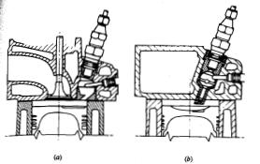
Fuel is usually injected into the auxiliary chamber at the lower injection-system pressure than is typical of DI systems through a pintle nozzle as a single spray, as shown in fig. Combustion starts in the auxiliary chamber : the pressure rise associated with combustion forces fluid back into the main chamber where the jet issuing from the nozzle entrains and mixes with the main chamber air. The glow plug shown on the right of the pre chamber is a cold starting aid. The plug is heated prior to starting the engine to ensure ignition of fuel early in the engine cracking process.

COMPILED BY: SP.ARUNKUMAR, AP (SR.GR)/MECH

SRI RAMAKRISHNA INSTITUTE OF TECHNOLOGY, PACHAPALAYAM, COIMBATORE-10. 33 out of 99

ME 2041 - ADVANCED I.C. ENGINES

Two types of Indirect-injection diesel engine (a) swirl pre chamber (b) Turbulent pre chamber.

Combustion chambers

In order to study about the combustion chambers we require knowing the combustion process. The below given fig graph shows the various process of combustion in diesel engines.
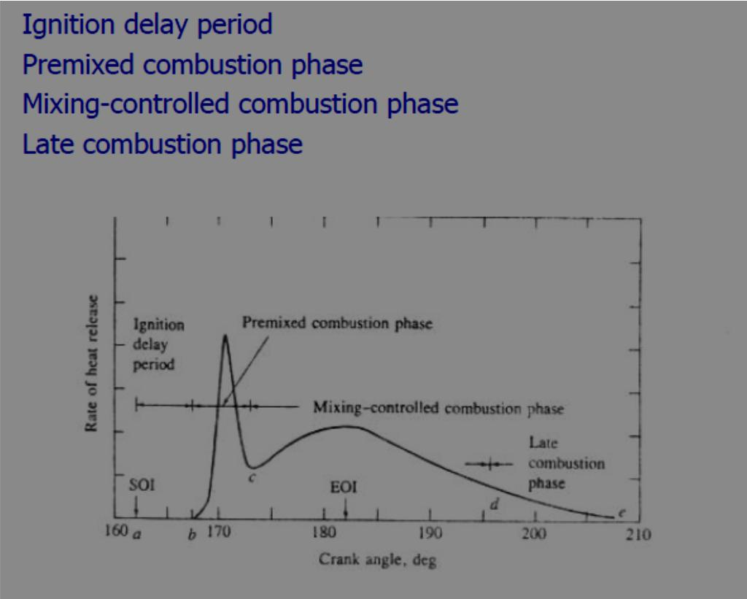

TURBO CHARGERS

Turbocharging:

Turbocharging is a method of increasing engine volumetric efficiency by forcing the air fuel mixture into the intake rather than merely allowing the pistons to draw it in naturally. Turbocharger:
A turbocharger uses the force of the engine exhaust stream to force the air fuel mixture into the engine. It consists of a housing containing two chambers. One chamber contains a turbine that is spun as hot exhaust gases are directed against it. The turbine shaft

COMPILED BY: SP.ARUNKUMAR, AP (SR.GR)/MECH

SRI RAMAKRISHNA INSTITUTE OF TECHNOLOGY, PACHAPALAYAM, COIMBATORE-10. 34 out of 99

ME 2041 - ADVANCED I.C. ENGINES

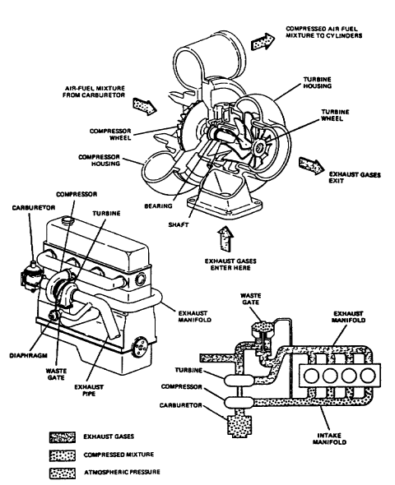
drives an impeller that is located in the other chamber. The spinning impeller draws an air fuel mixture from the carburetor and forces it into the engine. Because the volume of exhaust gases increases with engine load and speed, the turbocharger speed will increase proportionally, keeping the manifold pressure fairly uniform. A device known as a waste gate is installed on turbocharged engines to control manifold pressure. It is a valve which, when open, allows engine exhaust to bypass the turbocharger turbine, effectively reducing intake pressure. The wastegate valve is operated bya diaphragm that is operated by manifold pressure. The diaphragm will open the waste gate valve whenever manifold pressure reaches the desired maximum.

COMPILED BY: SP.ARUNKUMAR, AP (SR.GR)/MECH

SRI RAMAKRISHNA INSTITUTE OF TECHNOLOGY, PACHAPALAYAM, COIMBATORE-10. 35 out of 99

ME 2041 - ADVANCED I.C. ENGINES

Different types of Turbo-charging:

There are different types of turbocharging, they are 1. Constant pressure turbo-charging.
2. Pulse turbo charging (Buchi-type) 3. Pulse convertor turbo-charging. 4. Complex supercharger.
5. Two stage supercharger. Constant pressure turbo-charging:
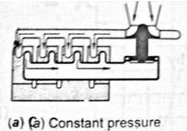
In this system, the exhaust pressure of the engine is constant and higher than atmospheric pressure so that the turbine can operate at an optimum efficiency. The objective dictates a large exhaust manifold to absorb pressure fluctuation and therefore the kinetic energy in the exhaust blow down is dissipated and becomes a reheat factor. This arrangement is shown in figure below.

The exhaust gases from the entire cylinder are released through exhaust valve at a

constant pressure in the common manifold and then to turbine. The blow-down energy in the form of internal energy is converted into work in the turbine. The recovery of blow down energy is higher if the pressure ratio of the turbine is high.
Advantages:

1. The pressure ratio is higher in turbine and compressors; the recovery of exhaust energy is efficient and is lower than other systems.
2. The turbine runs at higher efficiency because of constant pressure and temperature of the exhaust gases supplied to the turbine. This method is more efficient and effective than pulse system if the pressure ratio is 3 or higher.
3. The exhaust piping arrangement is very simple for multi cylinder engines and highly efficient turbine can be used.
4. Engine speed is no limited by the pressure waves in the exhaust pipes.

COMPILED BY: SP.ARUNKUMAR, AP (SR.GR)/MECH

SRI RAMAKRISHNA INSTITUTE OF TECHNOLOGY, PACHAPALAYAM, COIMBATORE-10. 36 out of 99

ME 2041 - ADVANCED I.C. ENGINES

5. Exhaust manifold being large to hold pressure fluctuations with ±5%, the pipe diameter is kept 1.4 times piston diameter. However, the insulation of exhaust manifold is essential to preserve the temperature of exhaust gases.

Disadvantages:

1. As the pressure in the exhaust manifold is maintained constant, this requires larger diameter of exhaust pipes. This effect is marked in case of small engines.
2. The response of the system to the load change is considerably poor. Because, acceleration occurs very slowly when load is suddenly increased. This is because, only a small amount of energy due to increased exhaust temperature is available to accelerate the engine at high loads.
3. For higher efficiency of the turbine, the higher pressure drop in the turbine is required. To achieve this, large pressure drop during release is required which makes scavenging a bit difficult (p2 / p1) is necessary and do not require acceleration and operation at part loads.
4. The part load ɳ of the turbine is reduced due to partial admission to the turbine.

5. This system is not suitable at all suitable for two strokes engines as it is impossible to run the compressor with the help of turbo charger alone and some additional means have to be provided for supplying the air to the engine.

Pulse turbo charging (Buchi-type):

The main objective of this system is to use the kinetic energy in the blow-down process to drive the turbine without increase in exhaust pressure. To accomplish this objective, the exhaust lines must be small and grouped to receive the exhaust pressure. To accomplish this objective, the exhaust lines must be small and grouped to receive the exhaust from cylinders which are blowing down at different times. This arrangement is shown in figure below.
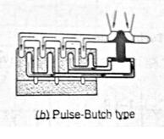

COMPILED BY: SP.ARUNKUMAR, AP (SR.GR)/MECH

SRI RAMAKRISHNA INSTITUTE OF TECHNOLOGY, PACHAPALAYAM, COIMBATORE-10. 37 out of 99

ME 2041 - ADVANCED I.C. ENGINES

Advantages:

1. The recovery system of the exhaust blow-down energy is more efficient is more efficient than constant pressure system.
2. Separate exhaust pipes are used so that the exhaust process of various cylinders do not interfere with one another. A common exhaust pipe can also be used for those cylinders whose exhaust cycles do not overlap significantly in terms of times.
3. The space required is less due to short and smaller diameter pipes.

4. Rapid acceleration of turbo charger to a higher speed can be fed to the turbine without delay.
5. Better scavenging can be obtained at low load due to reduced pressure in the exhaust manifold.

Disadvantages:

1. The recovery of energy is poor when the pressure ratio of turbine is high.

2. Complicated inlet and exhaust piping is required with the multi-cylinder engines. 3. The turbine efficiency becomes poor in case of one or two cylinder engines.
4. The scavenging process is disturbed if the waves have to travel long distance to reach to the turbine.

Application:

1. This system is widely used for low pressure ratio turbines and rapidly acceleration is

required.

2. This is generally used when numbers of cylinder are four or more and connected to a common exhaust pipe.

Pulse converter turbo-charging:

The pulse convertor has the advantages of pulse and the constant pressure turbo-

charging to be used simultaneously and avoids most of the drawbacks of both.

A constant pressure turbo-charging requires steady flow for maximum efficiency whereas pulse type turbo-charging operates relatively at lower efficiency due to partial operation. But pulse supercharging operates most efficiently at part load-condition and provides good scavenging also.

COMPILED BY: SP.ARUNKUMAR, AP (SR.GR)/MECH

SRI RAMAKRISHNA INSTITUTE OF TECHNOLOGY, PACHAPALAYAM, COIMBATORE-10. 38 out of 99

ME 2041 - ADVANCED I.C. ENGINES

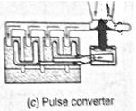
Therefore, a combination of two systems is essential for good efficiency during overall operation of the engine. This is done by connecting different branches of exhaust manifolds together in a specially designed for maximum pulse-system designed for maximum pulse utilisation is retained and the turbine run at full admission conditions to provide good efficiency.

Complex Supercharger:

The characteristics of turbo-chargers are fundamentally different from those reciprocating I.C engines and leads to complex matching problems when they are combined. Supercharger has added complication of mechanical drive and the compressor efficiencies are usually such that the overall economy is reduced. However, flow characteristics are better matched and transient response is good.

The pressure wave superchargers make use of the fact of two fluids having different pressures are bought into direct contact in long narrow channels; equalization of pressure occurs faster mixing. One such device, the complex, has been developed for I.C engine super-charging which operates using this principle.

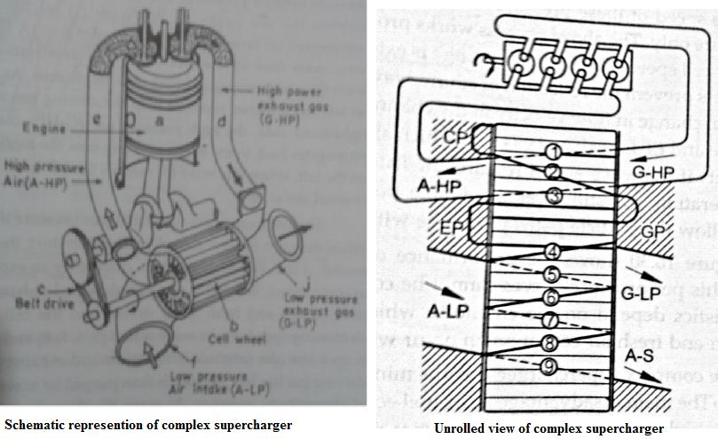

COMPILED BY: SP.ARUNKUMAR, AP (SR.GR)/MECH

SRI RAMAKRISHNA INSTITUTE OF TECHNOLOGY, PACHAPALAYAM, COIMBATORE-10. 39 out of 99

ME 2041 - ADVANCED I.C. ENGINES

Two stage supercharger:

For diesel engines, high supercharging is required as 25 to 30 bar BMEP is expected. This cannot be obtained in a single stage turbo-charging so a two stage is used as shown in figure given below.
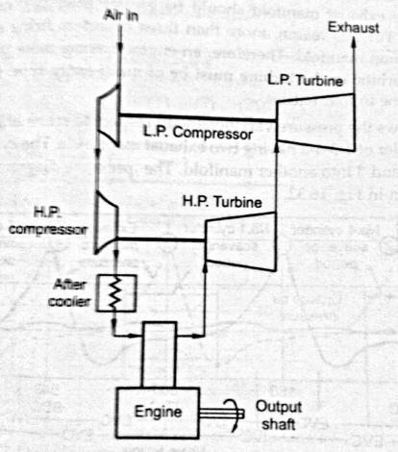

Advantages:

1. High pressure ratio can be obtained and provides wide range of operation.

2. The efficiency of two stages turbo-chargedis higher than single because of higher boost ratio. This gain is further increased by introducing after-cooler.
3. Better matching of turbocharger to engine operating conditions is possible.

4. The transient response of two stages turbo-charged is better than single stage.

Disadvantages:

1. The space requirement is higher.

2. It is heavier and costs higher.

3. Matching of turbo-charged with engine is quite difficult.

COMPILED BY: SP.ARUNKUMAR, AP (SR.GR)/MECH

SRI RAMAKRISHNA INSTITUTE OF TECHNOLOGY, PACHAPALAYAM, COIMBATORE-10. 40 out of 99

ME 2041 - ADVANCED I.C. ENGINES

Thermodynamic analysis of CI engines:

Cylinder pressure versus crank angle data over the compression and expansion strokes of the engine operating cycle can be used to obtain quantitative information on the progress of combustion. Suitable methods of analysis which yield the rate of release of the fuel's chemical energy (often called heat release), or rate of fuel burning, through the diesel engine combustion process will now be described. The method of analysis starts with the first law of thermodynamics for an open system which is quasi static (i.e., uniform in pressure and temperature). The first law for such a system

where dQ/dt is the heat-transfer rate across the system boundary into the system, p(dV/dt) is the rate of work transfer done by the system due to system boundaq mass flows across the system boundary displacement, ṁ, is the mass flow rate into the system across the system boundary at location i (flow out of the system would be negative), hi is the enthalpy of flux i entering or leaving the system, and U is, the energy of the material contained inside the system boundary.
The following problems make the application of this equation to diesel combustion difficult: 1. Fuel is injected into the cylinder. Liquid fuel is added to the cylinder which vaporizes and mixes with air to produce a fuel/lair ratio distribution which is nonunifom and varies with time. The process is not quasi static.
2. The composition of the burned gases (also nonuniform) is not known.

3. The accuracy of available correlations for predicting heat transfer in diesel which cannot be determined exactly.
4. Crevice regions (such as the volumes between the piston, rings, and cylinder wall) constitute a few percent of the clearance volume. The gas in the regions is cooled to close to the wall temperature, increasing its density and, therefore, the relative importance of these crevices. Thus crevices increase heat transfer and contain a nonnegligible fraction of the cylinder charge at conditions that are different from the rest of the combustion chamber.

Due to difficulties in dealing with these problems, both sophisticated method of analysis and more simple methods give only approximate answers.

COMPILED BY: SP.ARUNKUMAR, AP (SR.GR)/MECH

SRI RAMAKRISHNA INSTITUTE OF TECHNOLOGY, PACHAPALAYAM, COIMBATORE-10. 41 out of 99

ME 2041 - ADVANCED I.C. ENGINES

UNIT-III

ENGINE EXHAUST EMISSION CONTROL

Formation of NO:

Kinetics of NO formation:

While nitric oxide (NO) and nitrogen dioxide (NO2) are usually grouped together as Nox emissions, nitric oxide is the predominant oxide of nitrogen produced inside the engine cylinder. The principal source of NO is the oxidation of atmospheric (molecular) nitrogen. Gasoline contain negligible amounts of nitrogen: although diesel fuels contain more nitrogen, current levels are not significant.The mechanism of nitrogen formation is given below (Zeldovich Mechanism):
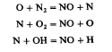

NO forms in both the flame front and the postflame gases. In engines however, combustion

occurs at high pressure so the flame reaction zone is extremely thin (-0.1 mm) and residence time within this zone is short. Also, cylinder pressure rises during most of the combustion process, so burned gases produced early in the combustion process are compressed to a higher temperature than they reached immediately after combustion. Thus, NO formation in the postflame gases almost always dominates any flame-front-produced NO. It is, therefore, appropriate to assume that the combustion and NO formation processes are decoupled and to approximate the concentrations of 0, O2, OH, H and N2by their equilibrium temperature.

The strong dependence of dPJO]/dt on temperature in the exponential term is evident. High temperatures and high oxygen concentrations result in high NO. Figure shows the NO formation rate as a function of gastemperature and fuel/air equivalence ratio in post flame gases. Also shown is the adiabatic flame temperature attained by a fuel-air mixture initially at 700 K at a constant pressure of 15 atm. For adiabatic constant-pressure combustion (an

COMPILED BY: SP.ARUNKUMAR, AP (SR.GR)/MECH

SRI RAMAKRISHNA INSTITUTE OF TECHNOLOGY, PACHAPALAYAM, COIMBATORE-10. 42 out of 99

ME 2041 - ADVANCED I.C. ENGINES

appropriate model for each element of fuel that burns in an engine), this initial NO formation rate peaks at the stoichiometric composition, and decreases rapidly as the mixture becomes leaner or richer.

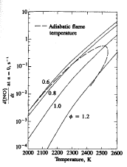

Formation of NO2

Chemical equilibrium considerations indicate that for burned gases at typical flame temperatures, NO2 / NO ratios should be negligibly small. While experimental data show this is true for spark ignition engines, in diesels NO2 can be 10 to 30 percent of the total exhaust oxides of nitrogen emissions. NO formed in the flame zone can be rapidly converted to NO2 via reactions such as

COMPILED BY: SP.ARUNKUMAR, AP (SR.GR)/MECH

SRI RAMAKRISHNA INSTITUTE OF TECHNOLOGY, PACHAPALAYAM, COIMBATORE-10. 43 out of 99

ME 2041 - ADVANCED I.C. ENGINES

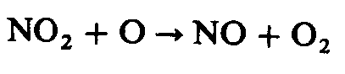
Important factors for formation of NO:

1. Equivalence ratio.

2. Burned gas formation. 3. Excess air.
4. Spark timing.

Formation of CO:

Carbon monoxide (CO) emissions from internal combustion engines are controlledprimarily by the fuel/air equivalence ratio. Figure 11-20 shows CO levelsin the exhaust of a conventional spark-ignition engine for several different fuelcompositions.27 When the data are plotted against the relative air/fuel ratio orthe equivalence ratio, they are correlated by a single curve. For fuel-rich mixturesCO concentrations in the exhaust increase steadily with increasing equivalenceratio, as the amount of excess fuel increases. For fuel-lean mixtures, CO concentrationsin the exhaust vary little with equivalence ratio and are of order 10-3 mole fraction. Since spark-ignition engines often operate close to stoichiometric at partload and fuel rich at full load, CO emissions are significant and mustbe controlled. Diesels, however, always operate well on the lean side of stoichiometric;CO emissions from diesels are low enough to be unimportant, therefore,and will not be discussed further.
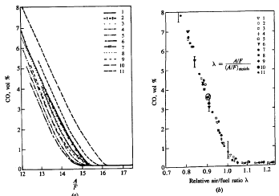

COMPILED BY: SP.ARUNKUMAR, AP (SR.GR)/MECH

SRI RAMAKRISHNA INSTITUTE OF TECHNOLOGY, PACHAPALAYAM, COIMBATORE-10. 44 out of 99

ME 2041 - ADVANCED I.C. ENGINES

The levels of CO observed in spark-ignition engine exhaust gases are lowerthan the maximum values measured within the combustion chamber, but arehigher than equilibrium values for the exhaust conditions. Thus theprocesses which govern CO exhaust levels are kinetically controlled. In premixedhydrocarbon-air flames, the CO concentration increases rapidly in the flame zoneto a maximum value, which is larger than the equilibrium value for adiabaticof the fuel-air mixture. CO formation is one of the principal reactionsteps in the hydrocarbon combustion mechanism, which may be summarized by

whereR stands for the hydrocarbon radical. The CO formed in the combustionprocess via this path is then oxidized to CO, at a slower rate. The principal COoxidation reaction in hydrocarbon-air flames is

CO increases rapidly as the inlet mixture becomes richer than stoichiometric ratio. And also improved cylinder-to-cylinder fuel/air ratio distribution has become essential. In addition to this, it is necessary to enrich the fuel-air mixture when the engine is cold since CO emission is higher at engine warm up.

Greenhouse effect (GHE)

Radiation from the sun always tries to passes through the earth. This wave length is usually shorter. This shortwave radiation when strikes the inner earth surface of green house, converts into heat long – wave radiation. This long wave radiation is again reflected back into atmosphere from the inside surfaces but it cannot go out as the atmosphere restricts the long wave going to out and traps the heat. This trapped heat (which should have happened without glass) contributes to warming of earth and provides energy for growth of plants. Therefore, this effect is known as greenhouse effect.

COMPILED BY: SP.ARUNKUMAR, AP (SR.GR)/MECH

SRI RAMAKRISHNA INSTITUTE OF TECHNOLOGY, PACHAPALAYAM, COIMBATORE-10. 45 out of 99

ME 2041 - ADVANCED I.C. ENGINES

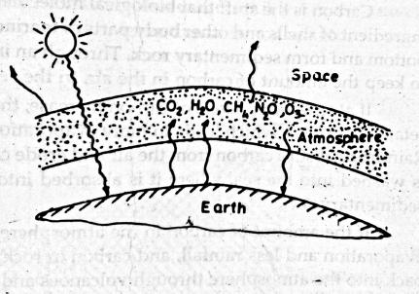

The presence of CO2 in earth atmosphere gives it the warmth essential for the substance of life. This happens because CO2 has peculiar optical properties. CO2 absorbs a good part of this long wave radiation, thus warming the globe. This is important life sustained that poses a threat to the human life in the coming decades.

CO2 is the chief and also CH4, NO2 and certain CFCs have similar effects. Collectively these gases are responsible for greenhouse effect, threatening an average increase in earth temperature by 1.5 to 5°C by the middle of this century which will seriously affect sea level, agriculture and forestry. From the ground, earth atmosphere is nearly invisible and easy to take for granted. From space, it is perceived more readily as a thin blanket of glasses, shielding the earth from sun’s UV – radiation and trapping the sun’s warmth to keep Earth Rivers and oceans from freezing. The greenhouse gases emitted into the atmospheric functions significantly, degrading the UV-shielding of O3– layer and intensifying the heat trapping properties of the atmosphere as a whole.

Factors affecting Greenhouse effect:

Carbon is the stuff that biological molecules are made of. In the oceans, it serves as

the basic ingredients of shells and other body parts of marine organisms, which eventually die and sink to the bottom and form sedimentary rock. Through an intricate feedback system, the earth has contrived to keep the amount of carbon in the air, in the sea on the land relatively constant.

COMPILED BY: SP.ARUNKUMAR, AP (SR.GR)/MECH

SRI RAMAKRISHNA INSTITUTE OF TECHNOLOGY, PACHAPALAYAM, COIMBATORE-10. 46 out of 99

ME 2041 - ADVANCED I.C. ENGINES

If the atmospheric levels of carbon increase, resulting greenhouse effect causes the earth to retain more heat, which leads to more evaporation of water from oceans and thus more rains. Rain drops absorb carbon from the air and erode carbon – laden rock; eventually the excess carbon is washed into the sea, where it is absorbed into seashells and returned to ocean bottom as sedimentary rocks.

If the amount of carbon in the atmosphere decreases, the process is reversed. There is less evaporation and less rainfall, carbon in rock at the ocean’s bottom eventually works its way back into the atmospheric through volcanoes and deep-sea vents.

The cycle operates over millions of years; however human disturbances such as the burning of fossils fuels and deforestation have outpaced this natural process, resulting in atmospheric carbon.

Steps taken to control greenhouse effect:

The greenhouse effect is overwhelming in scope and will specially impact on using

departments dealing with energy. In accordance with this, some of the steps have been taken by many countries which are as follows:

1. Increased usage of Natural gases instead of fuels which highly emit CO2. 2. Finding source and using more hydro-power.
3. Use of alternative energy.

4. Increasing the usage of nuclear power.

5. Using efficient equipment that controls CO2.

6. Eliminating the usage of CFC from refrigeration industry and finding the alternate refrigerant.
7. Increasing forestation and stopping deforestation.

8. Implementing methodology of tax charges respect to carbon emission by industries.

HC emission:

Hydrocarbons (HC) are the consequence of incomplete combustion of hydrocarbon fuel. The level of unburned hydrocarbons (HC) in the exhaust gases specified in

COMPILED BY: SP.ARUNKUMAR, AP (SR.GR)/MECH

SRI RAMAKRISHNA INSTITUTE OF TECHNOLOGY, PACHAPALAYAM, COIMBATORE-10. 47 out of 99

ME 2041 - ADVANCED I.C. ENGINES

terms of total hydrocarbon concentration expressed in parts per million carbon atoms. Engine exhaust gases contain a wide variety of hydrocarbon compounds.

HC is basically divided into two classes namely methane and non-methane

hydrocarbons. Below table shows classifications of hydrocarbons according to their relative reactivity which is the scale of 0 to 100based on their NO2 formation relatively to HC.
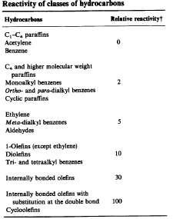

Smoke

Formations of smoke and affecting factors:

Engine Exhaust smoke is the result of incomplete combustion. Smoke from exhaust is a

visible indicator of the combustion process within the engine. It is generated at any volume in the engine where mixture is rich. The fuel air ratio greater than 1.5 and pressures developed in diesel engine produced soot. Once soot is formed, it can burn if it finds sufficient O2 otherwise it comes out with exhaust. It becomes visible if it is dense. The size of the soot

COMPILED BY: SP.ARUNKUMAR, AP (SR.GR)/MECH

SRI RAMAKRISHNA INSTITUTE OF TECHNOLOGY, PACHAPALAYAM, COIMBATORE-10. 48 out of 99

ME 2041 - ADVANCED I.C. ENGINES

particles effect the appearance of smoke. The soot particles agglomerate into bigger particles which have an objectionable darkening effect on diesel exhaust.

Measurement of smoke:

The main purpose of smoke measurement is to quantify the black smoke from

diesel engine. As visibility is the main criterion in evaluating the intensity of smoke, development or principle of the smoke meter depends on the light obstruction by the smoke.

Even though there are several smoke measuring types, two basic and main types are discussed in this lecture.

1. Hartridge smoke meter.

2. Bosch smoke meter.

Hartridge smoke meter:

The arrangement is shown in the figure. This consists of two optically

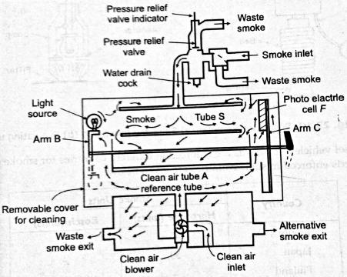
identical tubes, one containing clean air and other the moving sample of the smoke. The clean air tube is taken as reference. A light source and photo-electric cell mounted facing each other on swinging arms. Movement of the change-over knob alters their position from 0-100, indicating the light absorbed by the smoke in hartridge units. A small fan blows air into the clean air-tube. The air flow the open ends of the tube across the surfaces of the light source and the photo-electric cell, to provide cooling and to protect them against sooting by the smoke.

COMPILED BY: SP.ARUNKUMAR, AP (SR.GR)/MECH

SRI RAMAKRISHNA INSTITUTE OF TECHNOLOGY, PACHAPALAYAM, COIMBATORE-10. 49 out of 99

ME 2041 - ADVANCED I.C. ENGINES

The sampling probe is connected either to a tapping on the exhaust pipe. The smoke meter is switched on and control lever set to bring the clean air tube between light and cell. The smoke meter dial should read zero otherwise the meter is to adjusted to read zero. The control lever valve, the meter gives continuous and direct reading of the smoke density.

Bosch smoke meter:

The bosch meter is widely accepted for measuring the diesel engine smoke. This consists of sampling pump and evaluating unit shown in the figure given below. The sampling pump is used to draw nearly 300CC of exhaust gas by means of spring operated pump and released by pneumatic operation of a diaphragm. The gas sample is drawn is through the filter paper darkening to give precise assessment of the intensity of the spot. The intensity of the spot is measured on a scale of 10 arbitary units called arbitrary units, called Bosch smoke units for white to black.
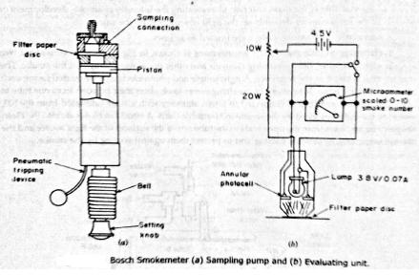

Particulate emissions:

Spark ignition particulates:

There are three classes of spark-ignition engine particulate emissions organic

particulates (including soot), and sulphates.

Significant sulphate emissions can occur with oxidation-catalyst engines. Unleaded gasoline contains 150 to 600 ppm by weight sulphur, which is oxidized within the engine cylinder to sulphur dioxide, SO2. This SO, can be oxidized by the exhaust catalyst to SO, which

COMPILED BY: SP.ARUNKUMAR, AP (SR.GR)/MECH

SRI RAMAKRISHNA INSTITUTE OF TECHNOLOGY, PACHAPALAYAM, COIMBATORE-10. 50 out of 99

ME 2041 - ADVANCED I.C. ENGINES

combines with water at ambient temperatures to form a sulphuric acid aerosol. Levels of sulphate emissions depend on the fuel sulphur content, the operating conditions of the engine, and the details of the catalyst system used. Typical average automobile sulphate emission rates are 20 mg/km or less.
The particle size distribution with leaded fuel is about 80 percent by mass below 2 μmdiametersabout 40 percent below 0.2 μm diameter. Most of these particles are presumed to form and grow in the exhaust system due to vapour phase condensation enhanced by coagulation. Some of the particles are emitted directly, without settling. Some of the particles either form or are deposited on the walls where agglomeration may occur. Many of these are removed when the exhaust flow rate is suddenly increased, and these particles together with rust and scale account for the increase in mass and size of particles emitted during acceleration. Only fraction (between 10 and 50 percent) of the lead consumed in the fuel is exhausted, the remainder being deposited within the engine and exhaust system.
.
Diesel particulates:

Diesel particulates consist of principally of combustion generated carbonaceous material (soot) on which some organic compounds has become absorbed. Most particulate material results from incomplete combustion of fuel hydrocarbons: some is contributed by the lubricating oil.The emission rates are typically 0.2 to 0.6 g/km for light duty diesels in an automobile. In larger direct injection engines, particulate emission rates are 0.5 to 1.5 g/brakeKW.h. The composition of particulate material depends on the conditions in the engine exhaust and particulate collection system. At temperatures above 500°C, the individual particles are principally clusters of many small spheres or spherules of carbon (with a small amount of hydrogen) with individual spherule diameter of about 15 to 30 mins. As temperature decreases: below 500°C, the particles become coated with absorbed and condensed high molecular weight organic compounds which include: unburned hydrocarbons, oxygenated hydrocarbons (ketones, esters, ethers, organic acids), and poly nuclear aromatic hydrocarbons. The condensed material also includes inorganic species such as sulphur dioxide, nitrogen dioxide and sulphuric acid 9 sulphates.

COMPILED BY: SP.ARUNKUMAR, AP (SR.GR)/MECH

SRI RAMAKRISHNA INSTITUTE OF TECHNOLOGY, PACHAPALAYAM, COIMBATORE-10. 51 out of 99

ME 2041 - ADVANCED I.C. ENGINES

Method of controlling emissions:

To reduce atmospheric pollution, two different approaches are followed:

1. To reduce the formation of pollutants in the emission by redesigning the engine system, fuel system, cooling system and ignition system.
2. By destroying the pollutants after these have been formed.

In petrol engine, the main pollutants which are objectionable and are to be reduced are HC,

CO and NOx. These methods are

a. Modifications in the engine design. b. Modifying the fuel used.
c. Exhaust gas treatment devices.

d. Evaporative emissive control devices.

Emission measuring equipment:

Infra-red Absorption Gas analyser for measuring CO:

Principle:

Infra-red radiation is absorbed by a wide range of gas molecules, each of which has characteristics absorption spectrum. The fraction of radiation (τλ) at a particular wavelength λ is given by Beer’s law as

-ρα L λ = (e) λ
τ

where ρ is gas density and αλ is the monochromatic absorbity and L is the path length.

Fig below shows the arrangement of this analyser. The detector cells are filled

with the gas that to be measured (CO of CO2), so that they absorb the radiation in the wave length band associated with that gas. The energy absorbed in the detector cells causes the cell pressure to rise. The reference cell is present in the sample then infra-red will be absorbed in the sample cell and less infra-red will be absorbed in the detector cell. This cell leads to a differential pressure in the detector cells which can be measured and related to the gas (CO) concentration. The calibration is carried out by passing gasses of known composition through the sample cell.

COMPILED BY: SP.ARUNKUMAR, AP (SR.GR)/MECH

SRI RAMAKRISHNA INSTITUTE OF TECHNOLOGY, PACHAPALAYAM, COIMBATORE-10. 52 out of 99

ME 2041 - ADVANCED I.C. ENGINES

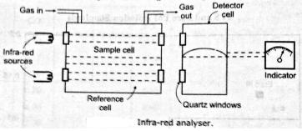

The below figure shows the absorption spectra of CO and CO2. This shows that, infra-red radiation is absorbed by both in the region of 4.4μ. This means that when CO2 is present in the sample, it will affect the reading of CO and vice versa. This problem is eliminated by using a filter cell between the infra-red sources and the sample and reference cells. If the CO is to be measured, then the filter cell is filled with CO2 and any CO2 in the sample should not lead to any infra-red absorption. The windows of the analyser should be made of such materials (mica or quartz) which are transparent to infra-red radiation.

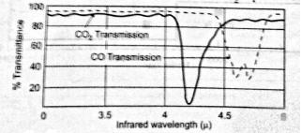
Transmittance of infra-red for CO & CO2

Flame ionisation detector for measuring HC-emissions:

Principle: When hydro-carbons are burned, electrons and positive ions are formed. If

unburned hydrocarbons are burned in the electric field, then the current flow corresponds very closely to the number of carbon atoms present.

Flame ionisation detector is shown in figure given below. The sample is mixed with the fuel and burned in air. The fuel should not cause any ionisation so a hydrogen-helium mixture is used. The air should be of high purity for reducing the risk of introducing hydrocarbons. The fuel and sample flows are to be regulated as the response of the instrument is directly proportional to the flow rate of sample as the influences the burner temperature. The flow is regulated by maintaining fixed pressure difference across the device.

COMPILED BY: SP.ARUNKUMAR, AP (SR.GR)/MECH

SRI RAMAKRISHNA INSTITUTE OF TECHNOLOGY, PACHAPALAYAM, COIMBATORE-10. 53 out of 99

ME 2041 - ADVANCED I.C. ENGINES

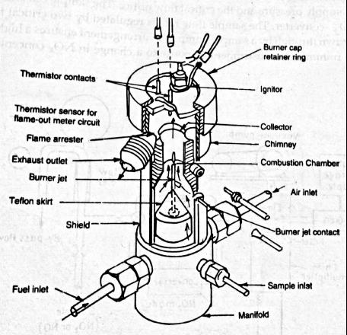
The burner jet and annular collector from the electrodes and a potential of about 100V is applied between them. The signals are amplified and calibration is achieved by zeroing instrument with a sample containing pure N2.

Chemiluminescence of measuring NO:

Principle: Chemiluminescence technique depends on the emission of light. NO (nitric oxide) reacts with O3 to produce NO2 in activated NO2 which emits in due course as it converts to normal state (NO2).

NO + O3 →NO2 + O2

NO2→NO2 + photon

The photon light emitted is proportional to the concentration of NO in the sample stream.

Both NO and NO2 exists in the engine exhaust NO2 can be measured by passing the sample over a catalyst that converts

2NO2→2NO + O2

By switching the convertor in and out of the sample line the concentration of NO and (NO + NO2) can be measured in the exhaust sample.

COMPILED BY: SP.ARUNKUMAR, AP (SR.GR)/MECH

SRI RAMAKRISHNA INSTITUTE OF TECHNOLOGY, PACHAPALAYAM, COIMBATORE-10. 54 out of 99

ME 2041 - ADVANCED I.C. ENGINES

Working

The below figure represents the key element of NOx, (NO + NO2) analyser. The vacuum pump controls the pressure in the reaction chamber and responsible for drawing in O3 and exhaust sample. The O3 is generated by an electric discharge in O2 at low pressure and flow of O3 is controlled by O2 supply pressure and the critical flow orifice. The sample can be either by-pass or flow through the NO2-convertor. The sample flow rate is regulated by two critical flow rate orifices. The bypass flow is drawn through by a sample pump. This arrangement ensures a high flow rate of sample gas, so as to minimise the instrument response to change in NOx concentration in the sample.
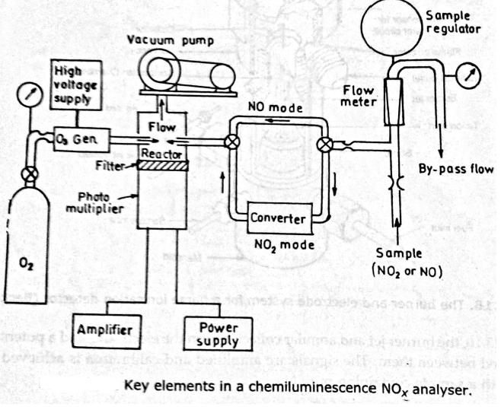

The flow of the sample into the reactor is controlled by the pressure differential across

the critical flow orifice upstream of the NOx converter. This pressure differential is controlled by a differential pressure regulator. The light emission in the reactor is measured by a photo multiplier and then amplified.

Catalytic convertor:

The catalytic converters used in spark-ignition engines consist of an active

catalyticmaterial in a specially designed metal casing which directs the exhaust gasflow through the catalyst bed. The active material employed for CO and HCoxidation or NO reduction (normally noble metals, though base metals oxidescan be used) must be distributed over a large surface area so that the masstransfercharacteristics between the gas phase and the active catalyst surface aresufficient to allow close to 100 percent conversion with high catalytic activity.The two configurations commonly used are shown in Fig. 11-53. One

COMPILED BY: SP.ARUNKUMAR, AP (SR.GR)/MECH

SRI RAMAKRISHNA INSTITUTE OF TECHNOLOGY, PACHAPALAYAM, COIMBATORE-10. 55 out of 99

ME 2041 - ADVANCED I.C. ENGINES

systememploys a ceramic honeycomb structure or monolith held in a metal can in theexhaust stream. The active (noble metal) catalyst material is impregnated into ahighly porous alumina washcoat about 20 pm thick that is applied to the passagewaywalls. The typical monolith has square-cross-section passageways with inside dimensions of ≅1 mm separated by thin (0.15 to 0.3 mm) porous walls.
The number of passageways per square centimetre varies between about 30 and60. The washcoat, 5 to 15 percent of the weight of the monolith, has a surfacearea of 100 to 200 m2/g. The other converter design uses a bed of sphericalceramic pellets to provide a large surface area in contact with the flow. With
pellet catalysts, the noble metal catalyst is impregnated into the highly poroussurface of the spherical alumina pellets (typically 3 mm diameter) to a depth ofabout 250 pm. The pellet material is chosen to have good crush and abrasionresistance after exposure to temperatures of order 1000•C. The gas flow isdirected down through the bed as shown to provide a large flow area and lowpressure drop. The gas flow is turbu
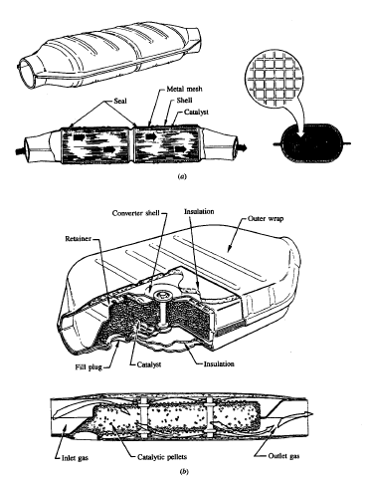

lent which results in high mass-transfer rates;in the monolith catalyst passageways, it is laminar.

COMPILED BY: SP.ARUNKUMAR, AP (SR.GR)/MECH

SRI RAMAKRISHNA INSTITUTE OF TECHNOLOGY, PACHAPALAYAM, COIMBATORE-10. 56 out of 99

ME 2041 - ADVANCED I.C. ENGINES

Particulate traps:

An exhaust treatment technology that substantially reduces diesel engine particulateemissions is the trap oxidiir. A temperature-tolerant filter or trap removes the particulate material from the exhaust gas; the filter is then "cleaned off" by oxidizing the accumulated particulates. This technology is difficult to implement because: (1) the filter, even when clean, increases the pressure in the exhaust system; (2) this pressure increase steadily rises as the filter collects particulate matter; (3) under normal diesel engine operating conditions the collected particulate matter will not ignite and oxidize; (4) once ignition of the particulate occurs, the burnup process must be carefully controlled to prevent excessively high temperatures and trap damage or destruction. Trap oxidizers have been put into production for light-duty automobile diesel engines. Their use with heavy-duty diesel engines poses more difficult problems due to higher particulate loading and lower exhaust temperatures.
Types of particulate filters include: ceramic monoliths, alumina-coated wire mesh, ceramic foam, ceramic fiber mat, woven silica-fiber rope wound on a porous tube. Each of these has different inherent pressure loss and filtering efficiency. Regeneration of the trap by burning up the filtered particulate material can be accomplished by raising its temperature to the ignition point while providing oxygen-containing exhaust gas to support combustion and carry away the heat released. Diesel particulate matter ignites at about 500ºC to 600ºC. This is above the normal temperature of diesel exhaust so either the exhaust gas flowing through the trap during regeneration must be heated (positive regeneration) or ignition must be made to occur at a lower temperature with catalytic materials on the trap or added to the fuel (catalytic regeneration). Catalytic coatings on the trap reduce the ignition temperature by up to 200°C.

Chemical methods to reduce emissions

Development work has been done on large stationary engines using cyanuric acid to

reduce NOx emissions. Cyanuric acid is a low-cost solid material that sublimes in the exhaust flow. The gas dissociates, producing isocyanide that reacts with NOx to form N₂, H₂0, and CO₂• Operating temperature is about 500°C. Up to 95% NOx reduction has been achieved
with no loss of engine performance.

COMPILED BY: SP.ARUNKUMAR, AP (SR.GR)/MECH

SRI RAMAKRISHNA INSTITUTE OF TECHNOLOGY, PACHAPALAYAM, COIMBATORE-10. 57 out of 99

ME 2041 - ADVANCED I.C. ENGINES

At present, this system is not practical for vehicle engines because of its size, weight, and complexity. Research is being done using zeolite molecular sieves to reduce NOx emissions. These are materials that absorb selected molecular compounds and catalyse chemical reactions. Using both SI and CI engines, the efficiency of NOx reduction is being determined over a range of operating variables, including AF, temperature, flow velocity, and zeolite structure. At present, durability is a serious limitation with this method.

Various chemical absorbers, molecular sieves, and traps are being tested to reduce HC emissions. HC is collected during engine startup time, when the catalytic converter is cold, and then later released back into the exhaust flow when the converter is hot. The converter then efficiently burns the HC to H₂0 and CO₂• A 35%
reduction of cold-start HC has been achieved.

H2S emissions occur under rich operating conditions. Chemical systems are being developed that trap and store H2S when an engine operates rich and then convert this to S02 when operation is lean and excess oxygen exists. The reaction equation is

H2S + 02 = S02 + H2 Ammonia Injection Systems

Some large ship engines and some stationary engines reduce NOx emissions with an

injection system that sprays NH3 into the exhaust flow. In the presence of a catalyst, the following reactions occur:

4 NH3 + 4 NO + 02 = 4 N2 + 6 H20 6 N02 + 8 NH3 = 7 N2 + 12 H20
Careful control must be adhered to, as NH3 itself is an undesirable emission. Emissions from large ships were not restricted for many years, even after strict laws were enforced on other engines. It was reasoned that ships operated away from land masses most of the time and the exhaust gases could be absorbed by the atmosphere without affecting human habitat. However, most seaports are in large cities, where emission problems are most critical, and polluting from all engines is now restricted, incl.Mdingship engines.

COMPILED BY: SP.ARUNKUMAR, AP (SR.GR)/MECH

SRI RAMAKRISHNA INSTITUTE OF TECHNOLOGY, PACHAPALAYAM, COIMBATORE-10. 58 out of 99

ME 2041 - ADVANCED I.C. ENGINES

Ammonia injection systems are not practical in automobiles or on other smaller engines. This is because of the needed NH3 storage and fairly complex injection and control system.

EXHAUST GAS RECYCLE-EGR

The most effective way of reducing NOx emissions is to hold combustion chamber

temperatures down. Although practical, this is a very unfortunate method in that it also reduces the thermal efficiency of the engine. We have been taught since infancy in our first thermodynamics course that for maximum engine thermal efficiency, Qin should be at the highest temperature possible.
Probably the simplest practical method of reducing maximum flame temperature is to dilute the air-fuel mixture with a non-reacting parasite gas. This gas absorbs energy during combustion without contributing any energy input. The net result is a lower flame temperature. Any non-reacting gas would work as a diluent, as shown in Fig. Those gases with larger specific heats would absorb the most energy per unit mass and would therefore require the least amount; thus less C0₂ would be required than argon for the same maximum temperature. However, neither C0₂ nor argon is readily available for use in an engine. Air is available as a diluent but is not totally non-reacting. Adding air changes the AF and combustion characteristics. The one
Non-reacting gas that is available to use in an engine is exhaust gas, and this is used in all modern automobile and other medium-size and large engines.

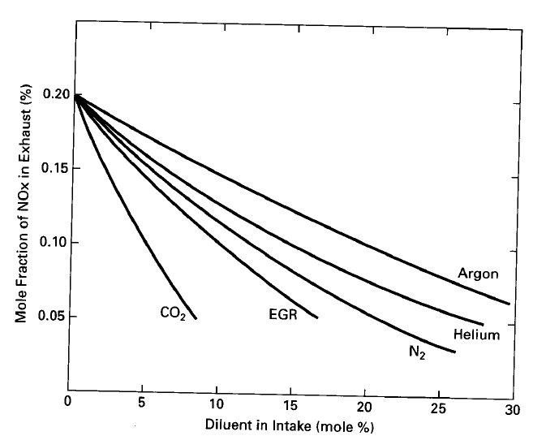

COMPILED BY: SP.ARUNKUMAR, AP (SR.GR)/MECH

SRI RAMAKRISHNA INSTITUTE OF TECHNOLOGY, PACHAPALAYAM, COIMBATORE-10. 59 out of 99

ME 2041 - ADVANCED I.C. ENGINES

Exhaust gas recycle (EGR) is done by ducting some of the exhaust flow back into the intake system, usually immediately after the throttle. The amount of flow can be as high as 30% of the total intake. EGR gas combines with the exhaust residualleft in the cylinder from the previous cycle to effectively reduce the maximum combustion temperature.
Not only does EGR reduce the maximum temperature in the combustion chamber, but it also lowers the overall combustion efficiency. Above Fig shows that as EGR are increased, the percent of inefficient slow-burn cycles increases. Further increase in EGR results in some cycle partial burns and, in the extreme, total misfires. Thus, by using EGR to reduce NOx emissions, a costly price of increased HC emissions and lower thermal efficiency must be paid.
The amount of EGR is controlled by the EMS. By sensing inlet and exhaust conditions the flow is controlled, ranging from 0 up to 15-30%. Lowest NOx emissions with relatively good fuel economy occur at about stoichiometric combustion, with as much EGR as possible without adversely affecting combustion. No EGR is used during WOT, when maximum power is desired. No EGR is used at idle and very little at low speeds. Under these conditions, there is already maximum exhaust residual and greater combustion inefficiency. Engines with fast-burn combustion chambers can tolerate a greater amount of EGR.

A problem unique to CI engines when using EGR is the solid carbon soot in the exhaust. The soot acts as an abrasive and breaks down the lubricant. Greater wear on the piston rings and valve train results.

NON EXHAUST EMISSIONS:

Engines and fuel supply systems also have sources of emissions other than exhaust flow. Historically, these were considered minor and were just released to the surrounding air.
A major source of HC emissions was the crankcase breather tube that was vented to the air in older automobiles. Blowby flow past the pistons ended up in the crankcase, and due to the higher pressure it created, it was then pushed out the breather vent tube. Blowby gas is very high in HCs, especially in 81 engines. Also, inolder engines with greater clearance between the piston and cylinder wall, blowby flow was much higher. As much as 1% of the fuel was vented to the atmosphere through the crankcase breather in some automobiles. This accounted for up to 20% of total emissions. A simple solution to this problem, which is used on all modernengines, is to vent the crankcase breather back into the intake system. This not onlyreduces emissions but also increases fuel economy.

COMPILED BY: SP.ARUNKUMAR, AP (SR.GR)/MECH

SRI RAMAKRISHNA INSTITUTE OF TECHNOLOGY, PACHAPALAYAM, COIMBATORE-10. 60 out of 99

ME 2041 - ADVANCED I.C. ENGINES

To keep the pressure at one atmosphere in the fuel tank and in the fuel reservoir of a carburetor, these systems are vented to the surroundings. Historically, these vents were an additional source of HC emissions when fuel evaporated from these fuel reservoirs. To eliminate these emissions, fuel vents now include someform of filter or absorption system which stops the HC vapour from escaping. One such system absorbs the HCs onto the surface of a carbon filter element. Then, when the engine is operating, the element is back flushed and the HC is desorbed off the surface. The recovered HC is ducted into the engine intake with no resulting emissions.
Many modern gasoline pumps and other fuel-dispensing systems are equipped with vapour-collecting nozzles that reduce HC vapour lost to the atmosphere during refuelling.

COMPILED BY: SP.ARUNKUMAR, AP (SR.GR)/MECH

SRI RAMAKRISHNA INSTITUTE OF TECHNOLOGY, PACHAPALAYAM, COIMBATORE-10. 61 out of 99

