ME 2041 - ADVANCED I.C. ENGINES

UNIT-IV
ALTERNATE FUELS

Sometime during the 21st century, crude oil and petroleum products will become very scarce and costly to find and produce. At the same time, there will likely be an increase in the number of automobiles and other IC engines. Although fuel economy of engines is greatly improved from the past and will probably continue to beimproved, numbers alone dictate that there will be a great demand for fuel in the coming decades. Gasoline will become scarce and costly. Alternate fuel technology, availability, and use must and will become more common in the coming decades. Although there have always been some IC engines fuelled with non-gasoline or diesel oil fuels, their numbers have been relatively small. Because of the high cost of petroleum products, some third-world countries have for many years been using manufactured alcohol as their main vehicle fuel. Many pumping stations on natural gas pipelines use the pipeline gas to fuel the engines driving the pumps. This solves an otherwise complicated problem of delivering fuel to the pumping stations, many of which are in very isolated regions. Some large displacement engines have been manufactured especially for pipeline work. These consist of a bank of engine cylinders and a bank of compressor cylinders connected to the same crankshaft and contained in a single engine block similar to a V-style engine.

Alcohols

Alcohols are an attractive alternate fuel because they can be obtained from a number

of sources, both natural and manufactured. Methanol (methyl alcohol) and ethanol (ethyl alcohol) are two kinds of alcohol that seem most promising and have had the most development as engine fuel.

The advantages of alcohol as a fuel include:

1. Can be obtained from a number of sources, both natural and manufactured.

2. Is high octane fuel with anti-knock index numbers (octane number on fuel pump) of over 100. High octane numbers result, at least in part, from the high flame speed of alcohol. Engines using high-octane fuel can run more efficiently by using higher compression ratios.

COMPILED BY: SP.ARUNKUMAR, AP (SR.GR)/MECH

SRI RAMAKRISHNA INSTITUTE OF TECHNOLOGY, PACHAPALAYAM, COIMBATORE-10. 62 out of 99

ME 2041 - ADVANCED I.C. ENGINES

3. Generally less overall emissions when compared with gasoline.

4. When burned, it forms more moles of exhaust, which gives higher pressure and more power in the expansion stroke.
5. Has high evaporative cooling (hfg) which results in a cooler intake process and compression stroke. This raises the volumetric efficiency of the engine and reduces the required work input in the compression stroke.
6. Low sulphur content in the fuel.

The disadvantages of alcohol fuels include:

1. Almost twice as much alcohol as gasoline must be burned to give the same energy input to the engine. With equal thermal efficiency and similar engine output usage, twice as much fuel would have to be purchased, and the distance which could be driven with a given fuel tank volume would be cut in half. The same amount of automobile use would require twice as much storage capacity in the distribution system, twice the number of storage facilities, and twice the volumeof storage at the service station, twice as many tank trucks and pipelines, etc. Even with the lower energy content of alcohol, engine power for a given displacement would be about the same. This is because of the lower air-fuel ratio needed by alcohol. Alcohol contains oxygen and thus requires less air for stoichiometric combustion. More fuel can be burned with the same amount of air.
2. More aldehydes in the exhaust. If as much alcohol fuel was consumed as gasoline, aldehyde emissions would be a serious exhaust pollution problem.
3. Alcohol is much more corrosive than gasoline on copper, brass, aluminium, rubber, and many plastics. This puts some restrictions on the design and manufacturing of engines to be used with this fuel. This should also be considered when alcohol fuels are used in engine systems designed to be used with gasoline. Fuel lines and tanks, gaskets, and even metal engine parts can deteriorate with long-term alcohol use (resulting in cracked fuel lines, the need for special fuel tank, etc). Methanol is very corrosive on metals.
4. Poor cold weather starting characteristics due to low vapour pressure and evaporation. Alcohol-fuelled engines generally have difficulty starting at temperatures below 10°C. Often a small amount of gasoline is added to alcohol fuel, which greatly improves cold-weather starting. The need to do this, however, greatly reduces the attractiveness of any alternate fuel.
5. Poor ignition characteristics in general.

COMPILED BY: SP.ARUNKUMAR, AP (SR.GR)/MECH

SRI RAMAKRISHNA INSTITUTE OF TECHNOLOGY, PACHAPALAYAM, COIMBATORE-10. 63 out of 99

ME 2041 - ADVANCED I.C. ENGINES

6. Alcohols have almost invisible flames, which are considered dangerous when handling fuel. Again, a small amount of gasoline removes this danger.
7. Danger of storage tank flammability due to low vapor pressure. Air can leak into storage tanks and create a combustible mixture.
8. Low flame temperatures generate less NOx, but the resulting lower exhaust temperatures take longer to heat the catalytic converter to an efficient operating temperature.
9. Many people find the strong odor of alcohol very offensive. Headaches and dizziness have been experienced when refuelling an automobile.
10. Vapour lock in fuel delivery systems.

Further Alcohols can be classified as two major types, they are:

- Methanol:
- Methanol

- Ethanol

Of all the fuels being considered as an alternate to gasoline, methanol is one of the

more promising and has experienced major research and development. Pure methanol and mixtures of methanol and gasoline in various percentages have been extensively tested in engines and vehicles for a number of years [88, 130]. The most common mixtures are M85 (85% methanol and 15% gasoline) and M10 (10% methanol and 90% gasoline). The data of these tests which include performance and emission levels are compared to pure gasoline (MO) and pure methanol (M100). Some smart flexible-fuel (or variable-fuel) engines are capable of using any random mixture combination of methanol and gasoline ranging from pure methanol to pure gasoline. Two fuel tanks are used and various flow rates of the two fuels can be pumped to the engine, passing through a mixing chamber. Using information from sensors in the intake and exhaust, the EMS adjusts to the proper air-fuel ratio, ignition timing, injection timing, and valve timing (where possible) for the fuel mixture being used. Fast, abrupt changes in fuel mixture combinations must be avoided to allow for these adjustments to occur smoothly.

One problem with gasoline-alcohol mixtures as a fuel is the tendency for alcohol to combine with any water present. When this happens the alcohol separates locally from the

COMPILED BY: SP.ARUNKUMAR, AP (SR.GR)/MECH

SRI RAMAKRISHNA INSTITUTE OF TECHNOLOGY, PACHAPALAYAM, COIMBATORE-10. 64 out of 99

ME 2041 - ADVANCED I.C. ENGINES

gasoline, resulting in a non- homogeneous mixture. This causes the engine to run erratically due to the large AF differences between the two fuels. At least one automobile company has been experimenting with a three-fuel vehicle which can use any combination of gasoline-methanol-ethanol. Methanol can be obtained from many sources, both fossil and renewable. These include coal, petroleum, natural gas, biomass, wood, landfills, and even the ocean. However, any source that requires extensive manufacturing or processing raises the price of the fuel and requires an energy input back into the overall environmental picture, both unattractive.

Emissions from an engine using MlO fuel are about the same as those using gasoline.

The advantage (and disadvantage) of using this fuel is mainly the 10% decrease in gasoline use. With M85 fuel there is a measurable decrease in HC and CO exhaust emissions. However, there is an increase in NOx and a large (= 500%) increase in formaldehyde formation.
Methanol is used in some dual-fuel CI engines. Methanol by itself is not a good CI fuel because of its high octane number, but if a small amount of diesel oil is used for ignition, it can be used with good results. This is very attractive for third-world countries, where methanol can often be obtained much cheaper than diesel oil.
Older CI bus engines have been converted to operate on methanol in tests conducted in California. This resulted in an overall reduction of harmful emissions compared with worn engines operating with diesel fuel.

- Ethanol

Ethanol has been used as automobile fuel for many years in various regions of the world. Brazil is probably the leading user, where in the early 1990s, 4.5 million vehicles operated on fuels that were 93% ethanol. For a number of years gasohol has been available at service stations in the United States, mostly in the Midwest corn-producing states. Gasohol is a mixture of 90% gasoline and 10% ethanol. As with methanol, the development of systems using mixtures of gasoline and ethanol continues. Two mixture combinations that are important are E85 (85% ethanol) and EI0 (gasohol). E85 is basically an alcohol fuel with 15% gasoline added to eliminate some of the problems of pure alcohol (i.e., cold starting, tank flammability, etc.). ElO reduces the use of gasoline with no modification needed to the automobile engine. Flexible-fuel engines are being tested which can operate on any ratio of ethanol-gasoline.

COMPILED BY: SP.ARUNKUMAR, AP (SR.GR)/MECH

SRI RAMAKRISHNA INSTITUTE OF TECHNOLOGY, PACHAPALAYAM, COIMBATORE-10. 65 out of 99

ME 2041 - ADVANCED I.C. ENGINES

Ethanol can be made from ethylene or from fermentation of grains and sugar. Much of it is made from corn, sugar beets, sugar cane, and even cellulose (wood and paper). In the United States, corn is the major source. The present cost of ethanol is high due to the manufacturing and processing required. This would be reduced if larger amounts of this fuel were used. However, very high production would create a food-fuel competition, with resulting higher costs for both. Some studies show that at present in the United States, crops grown for the production of ethanol consume more energy in ploughing, planting, harvesting, fermenting, and delivery than what is in the final product. This defeats one major reason for using an alternate fuel. Ethanol has less HC emissions than gasoline but more than methanol.

Hydrogen as alternate fuels

Hydrogen is a long-term renewable and less-polluting fuel. In addition hydrogen is clean burning characteristics and better performance drives more interest in hydrogen fuel. When it is burnt in an internal combustion engine, the primary combustion product is water with no CO₂. Although NOx emissions are formed when hydrogen is used.

Combustive Properties of Hydrogen

Wide range of flammability

Compared to nearly all other fuels, hydrogen has a wide flammability range (4-75% versus 1.4-7.6% volume in air for gasoline). This first leads to obvious concerns over the safe handling of hydrogen. But, it also implies that a wide range of fuel-air mixtures, including a lean mix of fuel to air, or, in other words, a fuel-air mix in which the amount of fuel is less than the stoichiometric, or chemically ideal, amount.
Small quenching distance

Hydrogen has a small quenching distance (0.6 mm for hydrogen versus 2.0 mm for gasoline), which refers to the distance from the internal cylinder wall where the combustion flame extinguishes. This implies that it is more difficult to quench a hydrogen flame than the flame of most other fuels, which can increase backfire since the flame from a hydrogen-air mixture more readily passes a nearly closed intake valve, than a hydrocarbon-air flame.

COMPILED BY: SP.ARUNKUMAR, AP (SR.GR)/MECH

SRI RAMAKRISHNA INSTITUTE OF TECHNOLOGY, PACHAPALAYAM, COIMBATORE-10. 66 out of 99

ME 2041 - ADVANCED I.C. ENGINES

Flame velocity and adiabatic flame

Hydrogen burns with a high flame speed, allowing for hydrogen engines to more closely approach the thermodynamically ideal engine cycle (most efficient fuel power ratio) when the stoichiometric fuel mix is used. However, when the engine is running lean to improve fuel economy, flame speed slows significantly.
Flame velocity and adiabatic flame temperature are important properties for engine operation and control, in particular thermal efficiency, combustion stability and emissions. Minimum ignition source energy
The minimum ignition source energy is the minimum energy required to ignite a fuel-air mix by an ignition source such as a spark discharge. For a hydrogen and air mix it is about an order of magnitude lower than that of a petrol-air mix 0.02 mJ as compared to 0.24 mJ for petrol - and is approximately constant over the range of flammability.
The low minimum ignition energy of the hydrogen-air mix means that a much lower energy spark is required for spark ignition. This means that combustion can be initiated with a simple glow plug or resistance hot-wire. It also ensures prompt ignition of the charge in the combustion chamber.
High diffusivity

Hydrogen has very high diffusivity. This ability to disperse into air is considerably greater than gasoline and is advantageous for two main reasons. Firstly, it facilitates the formation of a uniform mixture of fuel and air. Secondly, if a hydrogen leak develops, the hydrogen disperses rapidly. Thus, unsafe conditions can either be avoided or minimized
Low density

The most important implication of hydrogen’s low density is that without significant compression or conversion of hydrogen to a liquid, a very large volume may be necessary to store enough hydrogen to provide an adequate driving range. Low density also implies that the fuel-air mixture has low energy density, which tends to reduce the power output of the engine. Thus when a hydrogen engine is run lean, issues with inadequate power may arise. High auto-ignition temperature
The auto ignition temperature is the minimum temperature required to initiate self-sustained combustion in a combustible fuel mixture in the absence of an external ignition. For hydrogen, the auto ignition temperature is relatively high 585ºC. This makes it difficult of ignite a hydrogen–air mixture on the basis of heat alone without some additional ignition source. This temperature has important implications when a hydrogen–air mixture is compressed. In fact, the auto ignition temperature is an important factor in determining what

COMPILED BY: SP.ARUNKUMAR, AP (SR.GR)/MECH

SRI RAMAKRISHNA INSTITUTE OF TECHNOLOGY, PACHAPALAYAM, COIMBATORE-10. 67 out of 99

ME 2041 - ADVANCED I.C. ENGINES

maximum compression ratio an engine can use, since the temperature rise during compression is related to the compression ratio.
The temperature may not exceed hydrogen’s auto ignition temperature without causing premature ignition. Thus, the absolute final temperature limits the compression ratio. The high auto ignition temperature of hydrogen allows larger compression ratios to be used in a hydrogen engine than in a hydrocarbon engine.

Advantages of hydrogen as alternate fuel:

1. Hydrogen produces only water after combustion.

2H2 + O2 = 2H2O

2. When hydrogen is burned, hydrogen combustion does not produce toxic products such as hydrocarbons, carbon monoxide, and oxide of sulfur, organic acids or carbon dioxides
3. Hydrogen has some peculiar features compared to hydrocarbon fuels, the most significant being the absence of carbon.
4. The burning velocity is so high that very rapid combustion can be achieved.

5. The density of hydrogen is 0.0838 kg/m3, which is lighter than air that it can disperse into the atmosphere easily.
6. Hydrogen has the highest energy to weight ratio of all fuels.

Disadvantages of hydrogen as alternate fuels:

1. NOx is formed as emission.

2. Storage of hydrogen is more difficult as it leads to crack.

3. It is not possible to achieve ignition of hydrogen by compression alone. Some sources of ignition have to be created inside the combustion chamber to ensure ignition.
Formation of NOx depends on the factors like

• The air/fuel ratio

• The engine compression ratio

COMPILED BY: SP.ARUNKUMAR, AP (SR.GR)/MECH

SRI RAMAKRISHNA INSTITUTE OF TECHNOLOGY, PACHAPALAYAM, COIMBATORE-10. 68 out of 99

ME 2041 - ADVANCED I.C. ENGINES

• The engine speed

• The ignition timing

• Whether thermal dilution is utilized

Biogases as alternate fuels

Biogas is the product of fermentation of man and animals' biological activity waste products when bacteria degrade biological material in the absence of oxygen, in a process known as anaerobic digestion. Since biogas is a mixture of methane (also known as marsh gas or natural gas) and carbon dioxide it is a renewable fuel produced from waste treatment. Biogas contains 50% to 70% of CH₄, 2 % of H₂ and up to 30 % of CO₂. After being cleaned of carbon dioxide, this gas becomes a fairly homogeneous fuel containing up to 80 % of methane with the calorific capacity of over 25 MJ/m3. The most important component of biogas, from the calorific point of view, is methane, CH₄. The other components are not involved in combustion process, and rather absorb energy from combustion of CH4 as they leave the process at higher temperature than the one they had before the process.

The actual calorific value of biogas is function of the CH4 percentage, the temperature and the absolute pressure, all of which differ from case to case.

Economical and operational considerations:

a) Biogas availability or potential

- A biogas plant already exists and the gas yield is larger than what is already consumed in other equipment or the yield could be increased.
- Organic matter is available and otherwise wasted; the boundary conditions allow for anaerobic digestion. automobile engine. Flexible-fuel engines are being tested which can operate on any ratio of ethanol-gasoline.
- Environmental laws enforce anaerobic treatment of organic waste from food industries, distilleries, etc.

b) Demand for mechanical power municipalities,

- Other fuels are practically not available.

COMPILED BY: SP.ARUNKUMAR, AP (SR.GR)/MECH

SRI RAMAKRISHNA INSTITUTE OF TECHNOLOGY, PACHAPALAYAM, COIMBATORE-10 . 70 out of 99

ME 2041 - ADVANCED I.C. ENGINES

- Other sources of energy or fuels are more expensive or theirsupply is unreliable.
- Having a fuel at one's own disposal is of specific advantage.
c) Possible revenue through selling mechanical power, electric power orrelated services to other customers (e.g. the public electricity supplycompany).

Natural gas as Alternate fuel:

Natural gas is produced from gas wells or tied in with crude oil production. Natural

gas (NG) is made up primarily of methane (CH₄) but frequently contains trace amounts of ethane, propane, nitrogen, helium, carbon dioxide, hydrogen sulphide, and water vapour. Methane is the principal component of natural gas. Normally more than 90% of natural gas is methane.
Natural gas can be compressed, so it can stored and used as compressed natural gas (CNG).
CNG requires a much larger volume to store the same mass of natural gas and the use of very high pressure on about 200 bar or 2,900 psi.

Advantages of CNG:

1. Natural gas is safer than gasoline in many respects.

2. The ignition temperature for natural gas is higher than gasoline and diesel fuel.

3. Natural gas is lighter than air and will dissipate upward rapidly if a rupture occurs. 4. Gasoline and diesel will pool on the ground, increasing the danger of fire.
5. Compressed natural gas is non-toxic and will not contaminate groundwater if spilled.
6. Compressed natural gas is a largely available form of fossil energy and therefore non-renewable.
7. It is a cleaner fuel than either gasoline or diesel as far as emissions are concerned. Fuel Characteristics of CNG:
The octane rating of natural gas is about 130,meaning that engines could operate at compression ratio of up to 16:1 without “knock” or detonation.Many of the automotive makers already builttransportation with a natural gas fuelling system andconsumer does not

COMPILED BY: SP.ARUNKUMAR, AP (SR.GR)/MECH

SRI RAMAKRISHNA INSTITUTE OF TECHNOLOGY, PACHAPALAYAM, COIMBATORE-10. 70 out of 99

ME 2041 - ADVANCED I.C. ENGINES

have to pay for the cost ofconversion kits and required accessories. Mostimportantly, natural gas significantly reduces CO2emissions by 20-25% compare to gasoline becausesimple chemical structures of natural gas (primarilymethane – CH4) contain one Carbon compare to diesel(C15H32) and gasoline (C8H18). Like methane andhydrogen is a lighter than air type of gas and can beblended to reduce vehicle emission by an extra 50%.Natural gas composition varies considerably over timeand from location to location. Methane content istypically 70-90% with the reminder primarily ethane,propane and carbon dioxide. At atmosphericpressure and temperature, natural gas exists as a gas andhas low density. Since the volumetric energy density(joules/m3) is so low, natural gas is often stored in acompressed state (CNG) at high pressure stored inpressure vessels.
CNG Ideal operation:
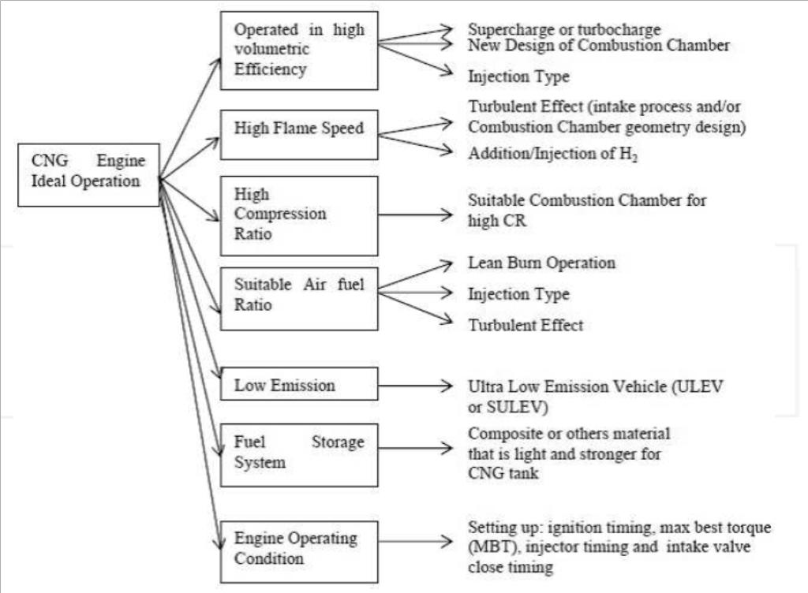

Injection methods of Natural Gas engine

There are four methods to inject the NG into the engine cylinder. First type is gas mixer / carburetor injection, second type is the single point injection, third type is multi point injection and fourth type is direct injection. The illustration of the four methods of NG injection is shown in Fig.

COMPILED BY: SP.ARUNKUMAR, AP (SR.GR)/MECH

SRI RAMAKRISHNA INSTITUTE OF TECHNOLOGY, PACHAPALAYAM, COIMBATORE-10. 71 out of 99

ME 2041 - ADVANCED I.C. ENGINES

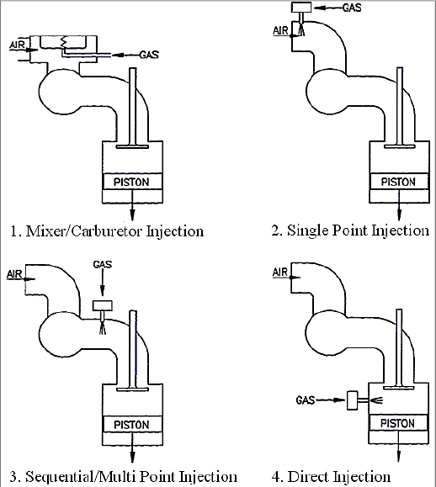
Vegetable oil as Alternate Fuel:

Vegetable oils used as DF as well as neat methyl esters prepared from vegetable oils or animal fats and blends of conventional diesel fuel with vegetable oils or methyl esters. Most vegetable oils are triglycerides (TGs; triglyceride = TG). Chemically, TGs are the triacylglycerol esters of various fatty acids with glycerol. The published engineering literature strongly indicates that the use of SVO will lead to reduced engine life. This reduced engine life is caused by the buildup of carbon deposits inside the engine, as well as negative impacts of SVO on the engine lubricant. Both carbon deposits and excessive build-up of SVO in the lubricant are caused by the very high boiling point and viscosity of SVO relative to the

COMPILED BY: SP.ARUNKUMAR, AP (SR.GR)/MECH

SRI RAMAKRISHNA INSTITUTE OF TECHNOLOGY, PACHAPALAYAM, COIMBATORE-10. 72 out of 99

ME 2041 - ADVANCED I.C. ENGINES

required boiling range for diesel fuel. The carbon buildup doesn’t necessarily happen quickly but instead over a longer period. These conclusions are consistent across a significant body of technical information in multiple articles and reports. Biodiesel is an alternative fuel that can be made from SVO in a chemical process called transesterification that involves a reaction with methanol using caustic soda (sodium hydroxide) as a catalyst. Biodiesel has substantially different properties than SVO and results in better engine performance. In particular, biodiesel has a lower boiling point and viscosity than SVO. Because of its improved qualities, vehicle and engine manufacturers generally approve the use of biodiesel blends in their products, though not all approve blend levels as high as 20%.

LPG as Alternate fuels:

LPG is typically a mixture of several gases in varying proportions. Major constituent gases are propane (C₃H₈) and butane (C₄H₁₀), with minor quantities of propane (C3H6), various butanes (C₄H8), iso-butane, and small amounts of ethane (C₂H₆). The composition of commercial LPG is quite variable. About 55% of the LPG processed from natural gas purification. The other 45% comes from crude oil refining. LPG is derived from petroleum; LPG does less to relieve the country’s dependency on foreign oil than some other alternative fuels. The gaseous nature of the fuel/air mixture in an LPG vehicle’s combustion chambers eliminates the cold-start problems associated with liquid fuels. LPG defuses in air fuel mixing at lower inlet temperature than is possible with either gasoline or diesel. This leads to easier starting, more reliable idling, smoother acceleration and more complete and efficient burning with less unburned hydrocarbons present in the exhaust. In contrast to gasoline engines, which produce high emission levels while running cold, LPG engine emissions remain similar whether the engine is cold or hot. Also, because LPG enters an engine’s combustion chambers as a vapor, it does not strip oil from cylinder walls or dilute the oil when the engine is cold. This helps to have a longer service life and reduced maintenance costs of engine. Also helping in this regard is the fuel’s high hydrogen-to-carbon ratio (C3H8), which enables propane-powered vehicles to have less carbon build-up than gasoline and diesel-powered vehicles. LPG delivers roughly the same power, acceleration, and cruising speed characteristics as gasoline. Its high octane rating means engine’s power output and fuel efficiency can be increased beyond what would be possible with a gasoline engine without causing Destructive Knocking.

COMPILED BY: SP.ARUNKUMAR, AP (SR.GR)/MECH

SRI RAMAKRISHNA INSTITUTE OF TECHNOLOGY, PACHAPALAYAM, COIMBATORE-10. 73 out of 99

ME 2041 - ADVANCED I.C. ENGINES

Such fine-tuning can help compensate for the fuel’s lower energy density. The higher ignition temperature of gas compared with petroleum based fuel leads to reduced auto ignition delays,less hazardous than any other petroleum based fuel and expected to produce less CO, NOx emissions and may cause less ozone formation than gasoline and diesel engines.

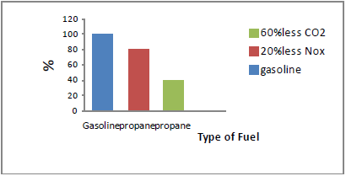

LPG engines similar to petrol engines, and deliver nearly similar performance and good in combustion characteristics than Gasoline. In the short term, LPG as a alternative fuels reviewed could displace 10 per cent of current usage of oil, or bring significant reductions in CO, CO2 emissions and help to reduce harmful greenhouse gas emissions. In the next five to ten years, LPG will be more widely available and gaining market share across vehicle ranges.

COMPILED BY: SP.ARUNKUMAR, AP (SR.GR)/MECH

SRI RAMAKRISHNA INSTITUTE OF TECHNOLOGY, PACHAPALAYAM, COIMBATORE-10. 74 out of 99

ME 2041 - ADVANCED I.C. ENGINES

Performance, combustion and emission characteristics of SI and CI engines

Testing procedure

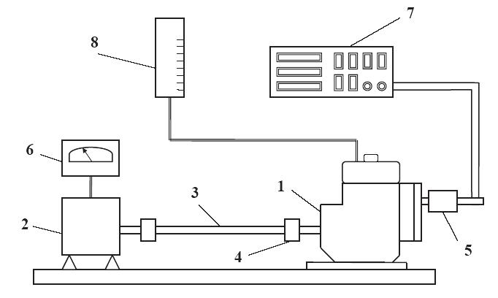

The schematic diagram of the experimental set-up.
(1) Engine, (2) Dynamometer, (3) Shaft, (4) Flywheel, (5) Exhaust pipe, (6) Dynamometer control unit, (7) Gas analyzer, and (8) Fuel measurement system.

Experimental results of engine performance characteristics using different ethanol gasoline blended fuels under various engine speeds.
(a) Brake power,
(b) Brake torque, and
(c) Brake specific fuel consumption.

COMPILED BY: SP.ARUNKUMAR, AP (SR.GR)/MECH

SRI RAMAKRISHNA INSTITUTE OF TECHNOLOGY, PACHAPALAYAM, COIMBATORE-10. 75 out of 99

ME 2041 - ADVANCED I.C. ENGINES

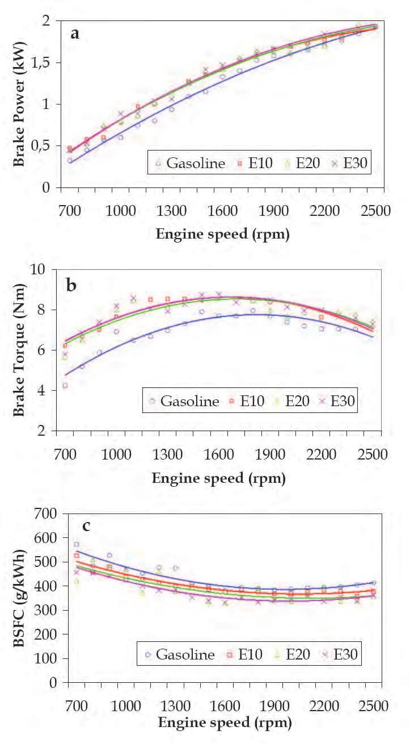

COMPILED BY: SP.ARUNKUMAR, AP (SR.GR)/MECH

SRI RAMAKRISHNA INSTITUTE OF TECHNOLOGY, PACHAPALAYAM, COIMBATORE-10. 76 out of 99

ME 2041 - ADVANCED I.C. ENGINES

Experimental results of engine performance characteristics using different methanol gasoline

blended fuels under various engine speeds. (a) Brake power, (b) Brake torque, and (c) Brake specific fuel consumption.

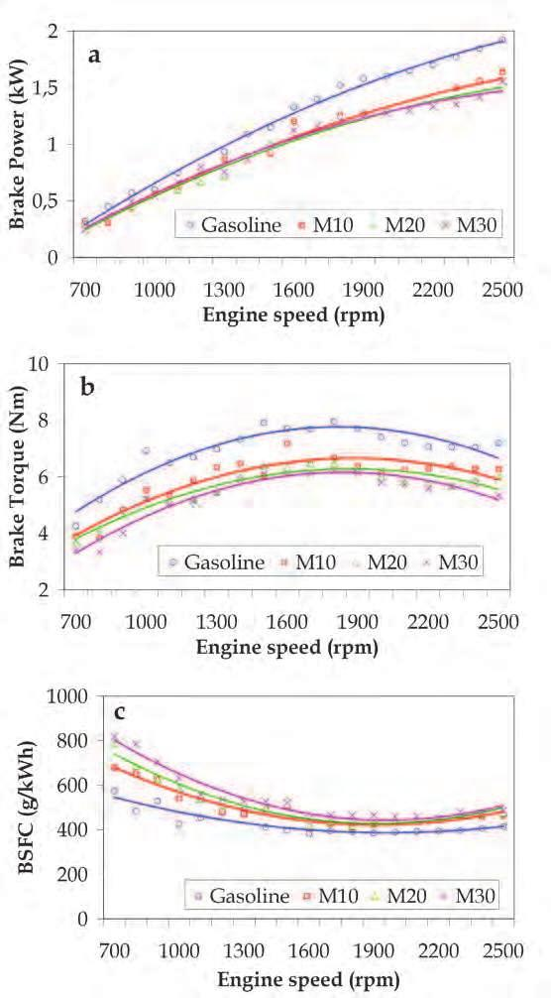
COMPILED BY: SP.ARUNKUMAR, AP (SR.GR)/MECH

SRI RAMAKRISHNA INSTITUTE OF TECHNOLOGY, PACHAPALAYAM, COIMBATORE-10. 77 out of 99

ME 2041 - ADVANCED I.C. ENGINES

The influence of ethanol addition on the engine performance characteristics. (a) Brake power, (b) Brake torque, and (c) Brake specific fuel consumption.

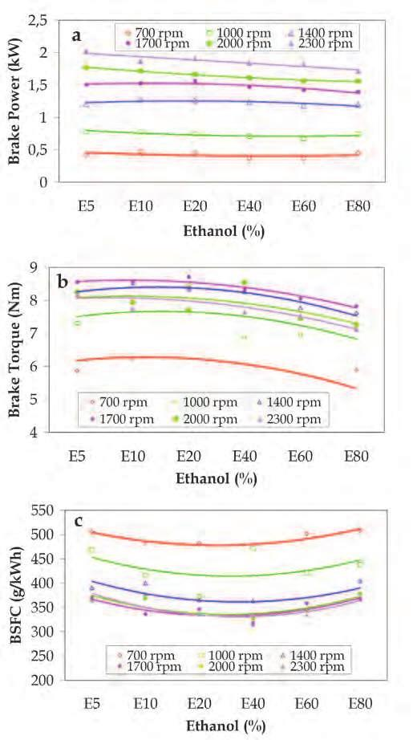

COMPILED BY: SP.ARUNKUMAR, AP (SR.GR)/MECH

SRI RAMAKRISHNA INSTITUTE OF TECHNOLOGY, PACHAPALAYAM, COIMBATORE-10. 78 out of 99

ME 2041 - ADVANCED I.C. ENGINES

The influence of methanol addition on the engine performance characteristics. (a) Brake power, (b) Brake torque, and (c) Brake specific fuel consumption.

COMPILED BY: SP.ARUNKUMAR, AP (SR.GR)/MECH

SRI RAMAKRISHNA INSTITUTE OF TECHNOLOGY, PACHAPALAYAM, COIMBATORE-10. 79 out of 99

ME 2041 - ADVANCED I.C. ENGINES

Comparison of brake power characteristics using different ethanol and methanolgasoline blended fuels.
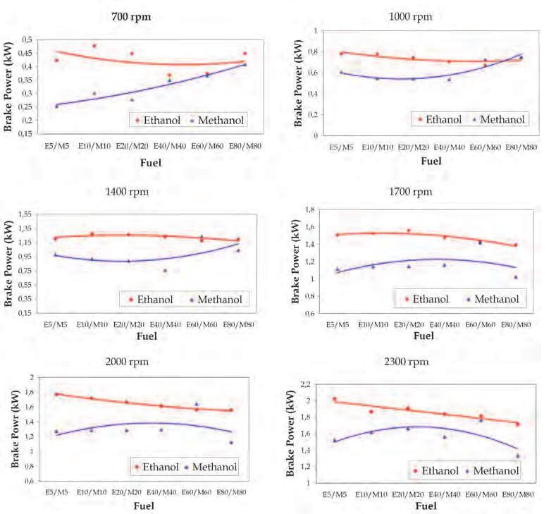

COMPILED BY: SP.ARUNKUMAR, AP (SR.GR)/MECH

SRI RAMAKRISHNA INSTITUTE OF TECHNOLOGY, PACHAPALAYAM, COIMBATORE-10. 80 out of 99

ME 2041 - ADVANCED I.C. ENGINES

Comparison of brake specific fuel consumption using different ethanol and methanol gasoline blended fuels.
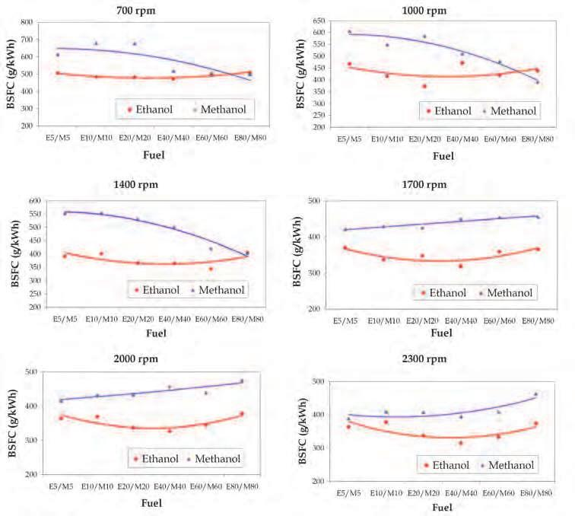

COMPILED BY: SP.ARUNKUMAR, AP (SR.GR)/MECH

SRI RAMAKRISHNA INSTITUTE OF TECHNOLOGY, PACHAPALAYAM, COIMBATORE-10. 81 out of 99

ME 2041 - ADVANCED I.C. ENGINES

The effect of various ethanol/methanol gasoline blend fuels on CO, CO₂, HC and NOx emissions.

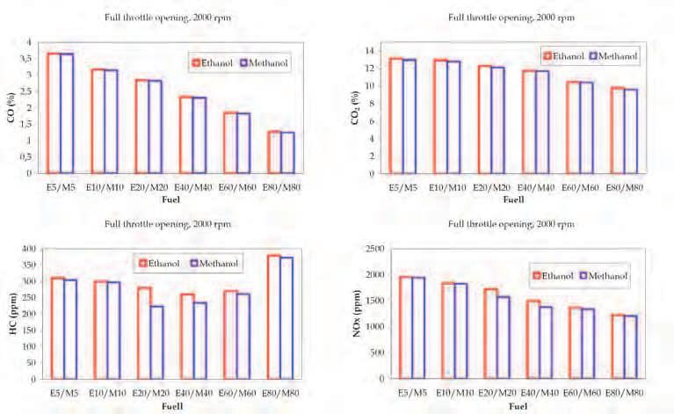

COMPILED BY: SP.ARUNKUMAR, AP (SR.GR)/MECH

SRI RAMAKRISHNA INSTITUTE OF TECHNOLOGY, PACHAPALAYAM, COIMBATORE-10. 82 out of 99

ME 2041 – ADVANCED I.C. ENGINES

UNIT – V
RECENT TRENDS

Homogeneous Charge Compression Ignition (HCCI)

● HCCI is an alternative piston-engine combustion process that can provide efficiencies

as high as compression-ignition, direct-injection (CIDI) engines (an advanced version of the commonly known diesel engine) while, unlike CIDI engines, producing ultra-low oxides of nitrogen (NOx) and particulate matter (PM) emissions.
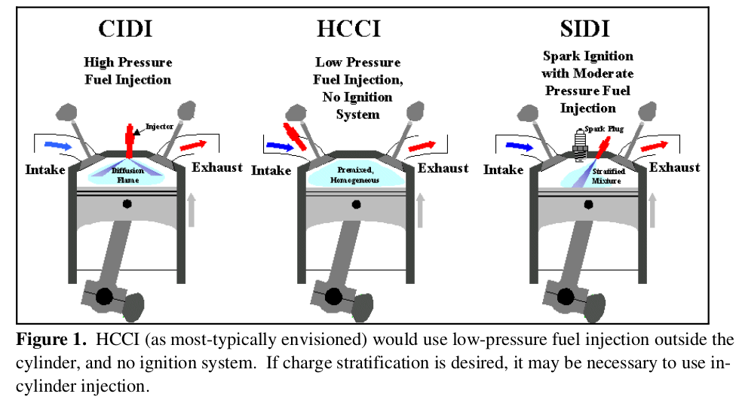

WORKING PRINCIPLE OF HCCI

Homogenous charge is drawn in to the cylinder during suction and compress to high

enough temperature to achieve spontaneous ignition of the charge.

After Combustion initiation the temperature rapidly increases and whole fuel burn

simultaneously.

As whole mixture burns simultaneously and no flame propagation, combustion temp can be controlled less than 700° Centigrade and thus NOx formation is avoided.

Advantages of HCCI:

COMPILED BY: SP.ARUNKUMAR, AP (SR.GR)/MECH
SRI RAMAKRISHNA INSTITUTE OF TECHNOLOGY, PACHAPALAYAM, COIMBATORE-10. 83 out of 99

ME 2041 – ADVANCED I.C. ENGINES

● HCCI engines are more efficient thus eliminating of throttling losses, the use of high compression ratios, and a shorter combustion duration.

● HCCI engines also have lower engine-out NOx than SI engines.

● Lower emissions of PM and Nox

● Because flame propagation is not required, dilution levels can be much higher than the levels tolerated by either SI or CIDI engines.

● The combustion duration in HCCI engines is much shorter than in CIDI engines since

it is not limited by the rate of fuel/air mixing. This leads to higher efficiency.

● HCCI engines may be lower cost than CIDI engines since they would likely use lower-pressure fuel-injection equipment.

Challenges of HCCI:

● Controlling Ignition Timing over a Range of Speeds and Loads.

● Extending the Operating Range to High Loads.

● Cold-Start Capability.

● Hydrocarbon and Carbon Monoxide Emissions.

STRATIFIED CHARGE ENGINE

● The principle of stratified charge applies to direct injection petrol engines.

● It involves concentrating spraying of the fuel close to the spark plug rather than

throughout the whole of the combustion chamber.

● This method of operation delivers a reduction in fuel consumption that can reach 40% when the engine is running at very low charge.

COMPILED BY: SP.ARUNKUMAR, AP (SR.GR)/MECH
SRI RAMAKRISHNA INSTITUTE OF TECHNOLOGY, PACHAPALAYAM, COIMBATORE-10. 84 out of 99

ME 2041 – ADVANCED I.C. ENGINES

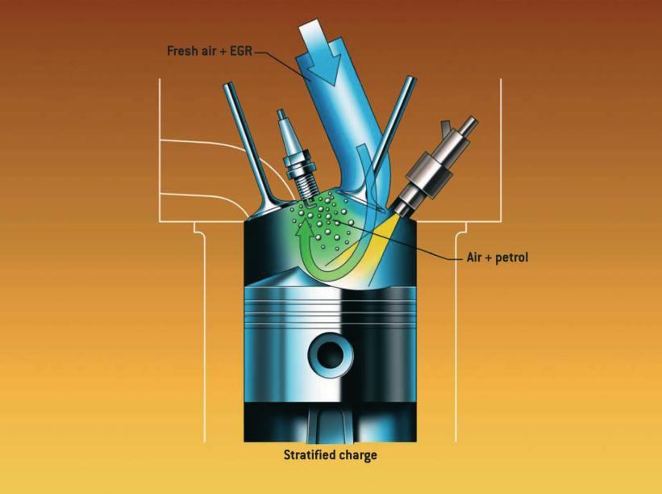

Basic principle:

The principle of the stratified charge engine is to deliver a mixture that is sufficiently rich for combustion in the immediate vicinity of the spark plug and in the remainder of the cylinder, a very lean mixture that is so low in fuel that it could not be used in a traditional engine. On an engine with stratified charge, the delivered power is no longer controlled by the quantity of admitted air, but by the quantity of petrol injected, as with a diesel engine.
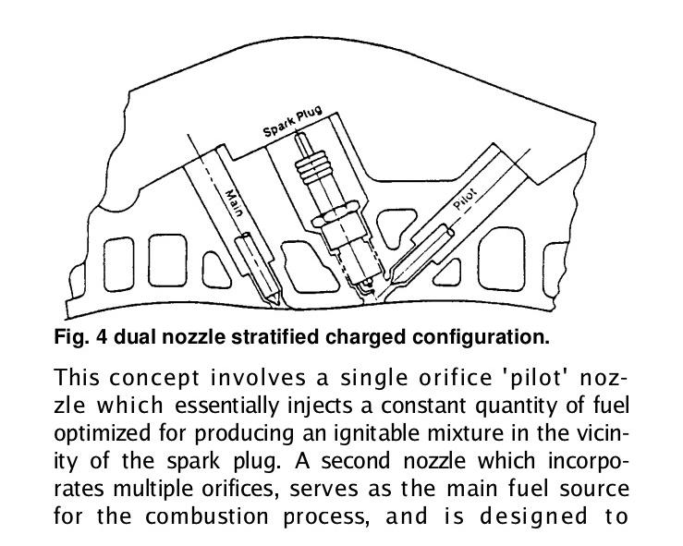

COMPILED BY: SP.ARUNKUMAR, AP (SR.GR)/MECH
SRI RAMAKRISHNA INSTITUTE OF TECHNOLOGY, PACHAPALAYAM, COIMBATORE-10. 85 out of 99

ME 2041 – ADVANCED I.C. ENGINES

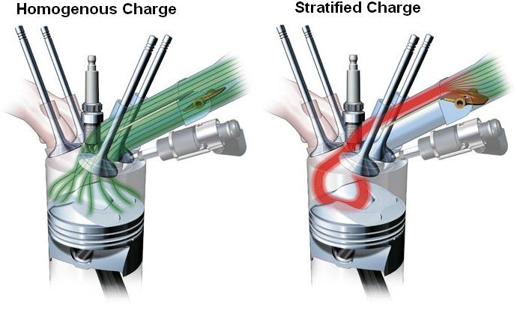

Gasoline Direct Ignition Engine

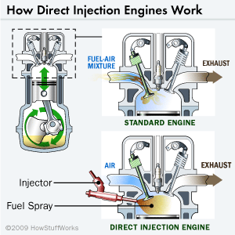

- First, the fuel travels via pump from the fuel tank, through the fuel line and into fuel

injectors that are mounted into the engine.

COMPILED BY: SP.ARUNKUMAR, AP (SR.GR)/MECH
SRI RAMAKRISHNA INSTITUTE OF TECHNOLOGY, PACHAPALAYAM, COIMBATORE-10. 86 out of 99

ME 2041 – ADVANCED I.C. ENGINES

• The injectors spray gasoline into the air intake manifold, where fuel and air mix

together into a fine mist. At precisely timed intervals, intake valves open, corresponding to the different cylinders of the engine.

• As a cylinder's intake valve opens, a piston in that cylinder descends, sucking the

fuel-air mist from the air manifold above into the chamber below. As the piston

ascends once more, it squeezes (compresses) the fuel-air mix until it is nearly nine times as dense as it was to begin with.

• Then, that cylinder's designated spark plug fires, igniting the chamber into a high-

pressure, high-energy explosion.

• This little bang pushes the piston back down with tremendous force, causing it to turn

the crankshaft and ultimately send power to the wheels.

• The ratio of air to fuel as it burns in an engine will have certain, predictable effects on

engine performance, emissions of pollutants and fuel efficiency.

• When the amount of air in the mixture is high, compared to the amount of fuel, it's

known as a "lean" mixture. When the reverse is the case, it's called a "rich" fuel

mixture.

• Direct injection engines use a mixture of 40 or more parts air to one part fuel, written

as 40:1.

• That compares to a normal gasoline engine's mix of 14.7:1. A leaner mixture allows

fuel to be burned much more conservatively.

• A second efficiency plus for direct injection engines is that they can burn their fuel

more completely.

• The fuel can be squirted directly where the combustion chamber is hottest -- in a

gasoline engine that means it ends up close to the spark.

• With a traditional gasoline engine, the fuel air mixture disperses widely within the

chamber, leaving a substantial amount unburned and therefore ineffective.

COMPILED BY: SP.ARUNKUMAR, AP (SR.GR)/MECH
SRI RAMAKRISHNA INSTITUTE OF TECHNOLOGY, PACHAPALAYAM, COIMBATORE-10. 87 out of 99

ME 2041 – ADVANCED I.C. ENGINES

Components of a Direct Injection gasoline System

Common Rail System -- A long metal cylinder called a fuel rail distributes fuel to the injectors under extremely high pressure.

Distributor and Inline Pump System -- Either a rotary wheel distributor or plunger-style pump is used to push pressurized fuel to the injectors.

Unit Direct System -- In this setup, the injector and a fuel pump just for that injector

are integrated into a single unit and positioned over each cylinder

Advantages over indirect injection:

Better MPG

Leaner fuel mixtures

High power output

Accurately controlled emissions levels

More aggressive ignition timing curves

Precise control over amount of fuel and injection timings

No throttling losses in engines without a throttle plate

Disadvantages:

Dramatic efficiency losses due to deposits on the piston surface.

More deposits on the intake ports and valves.

Low mileage misfire codes.

COMPILED BY: SP.ARUNKUMAR, AP (SR.GR)/MECH
SRI RAMAKRISHNA INSTITUTE OF TECHNOLOGY, PACHAPALAYAM, COIMBATORE-10. 88 out of 99

ME 2041 – ADVANCED I.C. ENGINES

Lean-burn engine

In response to this interest, manufacturers have introduced natural gas engine-powered generator sets that feature “lean-burn” technology. The combustion is considered “lean” when excess air is introduced into the engine along with the fuel.

Def:

Lean-burn means pretty much what it says. It is a lean amount of fuel supplied to and burned in an engine's combustion chamber. Normal air-to-fuel ratio is on the order of 15:1 (15 parts air to 1 part fuel). True lean-burn can go as high as 23:1.

Combustion process

Reduces the occurrence of “knocking” or detonation. To prevent either knocking or

misfiring, the combustion process must be controlled within a narrow operating window. Charge air temperatures and volume, together with air to fuel ratio, are constantly monitored. The micropro-cessor-based engine controller regulates the fuel flow and air/gas mixture and ignition timing.

Design of Engine

The design of the lean-burn engine incorporates a simple open combustion chamber housed in the piston crown. The shape of the piston crown introduces turbulence in the incoming air/fuel mixture that promotes more complete combustion by thoroughly exposing it to the advancing flame front. The flame plate of the cylinder head is regular (flat) and the spark plug is centrally located. The air and gas fuel are correctly mixed under the control of the engine management system.

Reduced Emisions

One of the results of this technology is significantly reduced emissions in the exhaust. Cummins’ new lean-burn gas engine generators have NOx emissions as low as .85 grams/BHP-hr, and produce low amounts of hydrocarbons (HC), carbon monoxide (CO) and particulate matter (PM). This allows the generator sets to meet the most stringent air quality regulations without after-treatment devices in the exhaust stream.

COMPILED BY: SP.ARUNKUMAR, AP (SR.GR)/MECH
SRI RAMAKRISHNA INSTITUTE OF TECHNOLOGY, PACHAPALAYAM, COIMBATORE-10. 89 out of 99

ME 2041 – ADVANCED I.C. ENGINES

Common Rail Diesel Fuel Systems

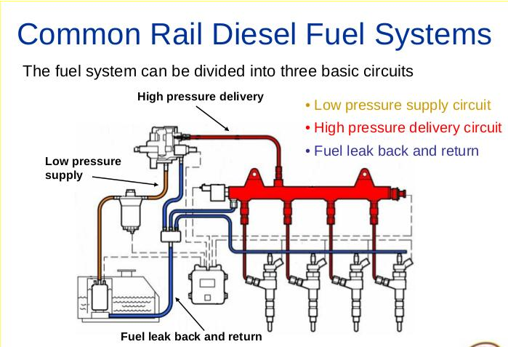

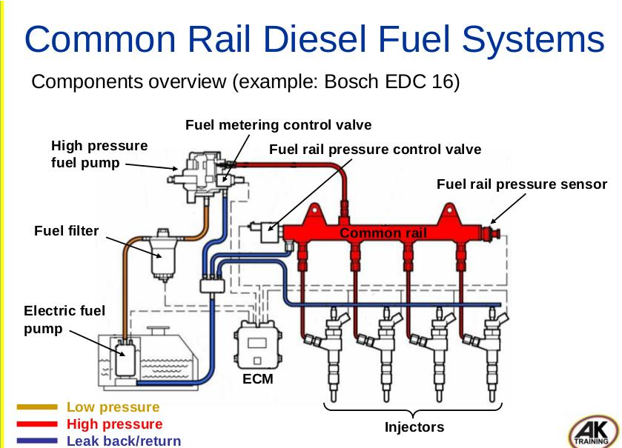

COMPILED BY: SP.ARUNKUMAR, AP (SR.GR)/MECH
SRI RAMAKRISHNA INSTITUTE OF TECHNOLOGY, PACHAPALAYAM, COIMBATORE-10. 90 out of 99

ME 2041 – ADVANCED I.C. ENGINES

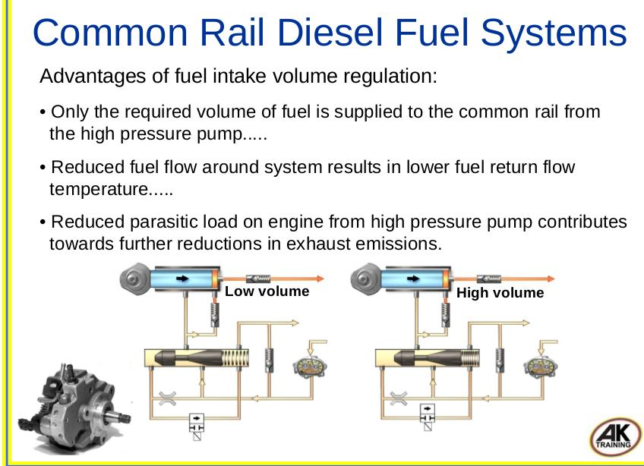

Common Rail Diesel Fuel Systems

● High pressure accumulator (common rail)

● Typical fuel rail pressure with engine idling and at running temperature:

● approximately between 300 – 400 Bar (4410 – 5880 psi)

● Health and safety

● Due to the extremely high working fuel pressures in the common

● rail fuel system, NEVER slacken fuel or injector pipes or try to

● disconnect components of the fuel system whilst the engine is

● running and high pressure is present in the system!

● Typical maximum possible fuel rail pressure:

COMPILED BY: SP.ARUNKUMAR, AP (SR.GR)/MECH
SRI RAMAKRISHNA INSTITUTE OF TECHNOLOGY, PACHAPALAYAM, COIMBATORE-10. 91 out of 99

ME 2041 – ADVANCED I.C. ENGINES

● approximately between 1600 – 2000 Bar (23520 – 28400 psi)

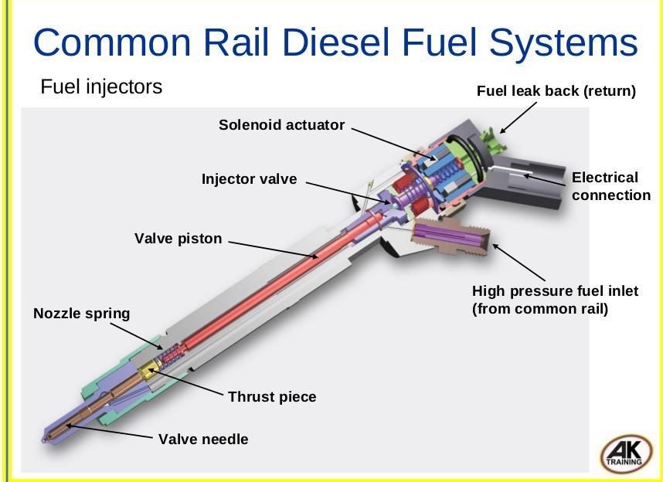

COMPILED BY: SP.ARUNKUMAR, AP (SR.GR)/MECH
SRI RAMAKRISHNA INSTITUTE OF TECHNOLOGY, PACHAPALAYAM, COIMBATORE-10. 92 out of 99

ME 2041 – ADVANCED I.C. ENGINES

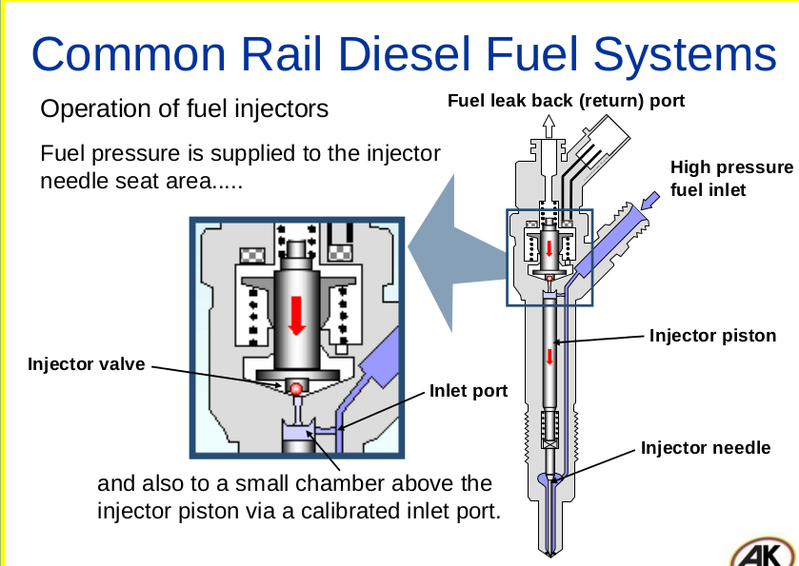

COMPILED BY: SP.ARUNKUMAR, AP (SR.GR)/MECH
SRI RAMAKRISHNA INSTITUTE OF TECHNOLOGY, PACHAPALAYAM, COIMBATORE-10. 93 out of 99

ME 2041 – ADVANCED I.C. ENGINES

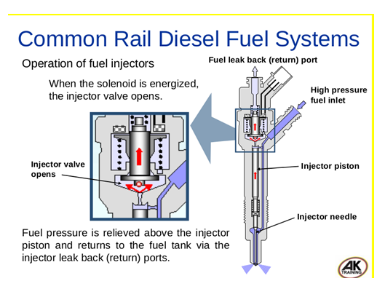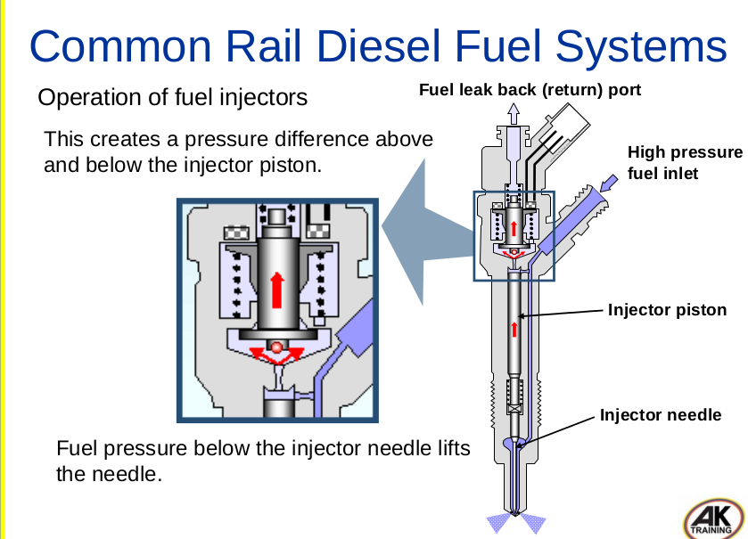

COMPILED BY: SP.ARUNKUMAR, AP (SR.GR)/MECH
SRI RAMAKRISHNA INSTITUTE OF TECHNOLOGY, PACHAPALAYAM, COIMBATORE-10. 94 out of 99

ME 2041 – ADVANCED I.C. ENGINES

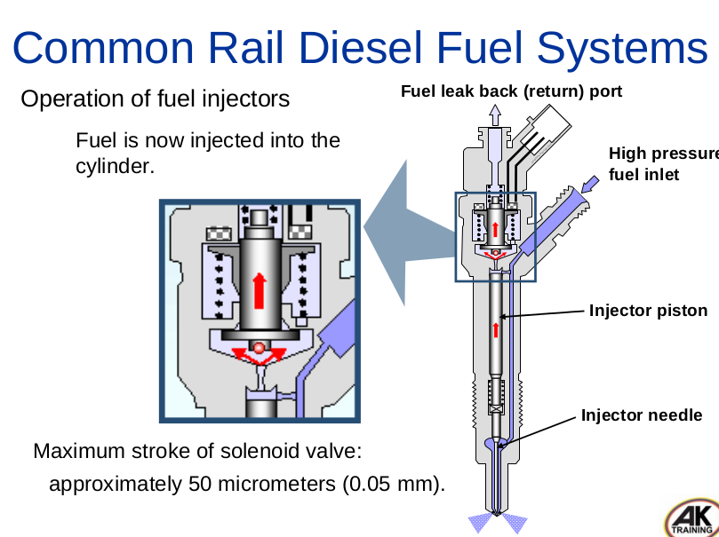

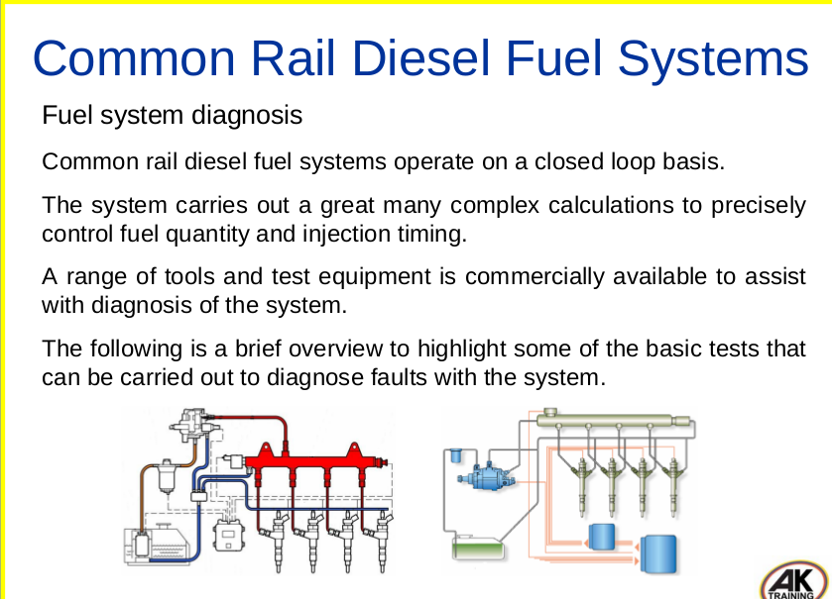

Advantages of common rail:

• Fuel pressure available on demand.....

• Higher injection pressures and finer atomization of fuel.....

• Injection pressure created independent of engine speed.....

• Multiple injections per cylinder combustion are possible.

COMPILED BY: SP.ARUNKUMAR, AP (SR.GR)/MECH
SRI RAMAKRISHNA INSTITUTE OF TECHNOLOGY, PACHAPALAYAM, COIMBATORE-10. 95 out of 99

ME 2041 – ADVANCED I.C. ENGINES

• Reduction of overall exhaust emissions.....

• Reduction of particulate emissions.....

• Reduction of noise emissions.....

• Improved fuel efficiency.....

• Higher performance.

Electronic Engine Management

Purpose of EEM:

Controlling of Engine operation electronically by electronic components.

Benefits to the motorist, more power, better mileage, a smoother idle and reduced

operation expenses.

Cost of components come down.

Engine become smaller in size.

Basic components:

1. Electronic Control Module

2. Fuel Delivery System

3. Ignition System

4. Sensors

Electronic Control Module:

It is a extremely reliable piece of hardware.

It process information hundreds of times per second.

It is actually a microprocessor.

COMPILED BY: SP.ARUNKUMAR, AP (SR.GR)/MECH
SRI RAMAKRISHNA INSTITUTE OF TECHNOLOGY, PACHAPALAYAM, COIMBATORE-10. 96 out of 99

ME 2041 – ADVANCED I.C. ENGINES

It is programmed by the Manufacturer.

It controls the fuel delivery and ignition timing by receiving information from

sensors.

Fuel Delivery system

The fuel line passes through which feeds each injector and it passes through a

pressure regulator.

The surplus fuel heading back to the tank in the return line. The air is taken from the

atmosphere. It is mixed with fuel just before the inlet valve by the fuel injector.

This fuel delivery system is controlled by ECU to provide lean and rich mixtures

depending on operating conditions.

Ignition system:

To maximize the Engine output, spark should be at the precise moment.

Maximum combustion chamber pressure can be attained.

A mechanical advance distributor is used for this.

A spark advance map is developed and stored in the ECU.

As the speed increases, the spark should be advanced further.

Sensors:

1 Throttle Position Sensor

The ECU senses how wide the throttle is opened.

The ECU controls fuel delivery and spark timing.

It consists of a wiper arm and resistor.

At idle, resistance is high, Voltage is .6-.9v.

As throttle presses, resistance decreases, voltage is 3.5-4.7v.

2. Exhaust gas oxygen sensor:

COMPILED BY: SP.ARUNKUMAR, AP (SR.GR)/MECH
SRI RAMAKRISHNA INSTITUTE OF TECHNOLOGY, PACHAPALAYAM, COIMBATORE-10. 97 out of 99

ME 2041 – ADVANCED I.C. ENGINES

It is placed in Engine’s exhaust system.

Consists of Zirconium Dioxide cell, provide precise indication of stoichiometric A/F

ratio.(14.7:1).

Zirconium Dioxide is the outer cell exposed to exhaust gas and inner electrode is

exposed to ambient air.

The output varies from 0v-1v.

At stoichiometric point it produces .45v

It provides precise output voltage measurements.

MAP sensor:

It senses the degree of vacuum in the engine intake manifold.

Vacuum decreases when throttle is opened/engine are under load.

A silicon chip (piezoelectric) is provided with a reference pressure one side.

Pressure to be measured is applied on the other side.

Variation in pressure causes change in resistance of the silicon chip.

It covers the amount of air drawn into voltage.

ECU senses it and calculates the engine load.

It is located at the intake air stream, between the air cleaner and throttle body.

Coolant temperature sensor:

ECU Senses the temperature and decides whether to activate/deactivate the cooling

fans in water cooled engines.

It helps to enrich the mixture for cold starting, and provide lean mixtures for fuel

economy.

It directly gives the engine operating temperature.

It is located on the coolant passage.

COMPILED BY: SP.ARUNKUMAR, AP (SR.GR)/MECH
SRI RAMAKRISHNA INSTITUTE OF TECHNOLOGY, PACHAPALAYAM, COIMBATORE-10. 98 out of 99

ME 2041 – ADVANCED I.C. ENGINES

It Consists of a fixed value resistor, supplied with 5V.

ECU Senses the change in voltage between the temperature sensor and the fixed value

resistor.

When the sensor is cold, resistance is high and voltage is increases.

As the temperature increases, the sensor resistance and the voltage decreases.

Knock Sensor:

It detects the engine knock occurs during combustion process, it is located in the

engine block.

Engine knocks within a specific frequency range.

It is a piezoelectric element, generates a voltage when a pressure or vibration is

applied.

Throttle and timing sensor:

It provides the information about how fast the engine is running or where the

crankshaft is in its rotation.

ECU senses this information and adjusts the fuel injection and the spark timing so that

the engine speed does not exceed the safe operating limits.

These sensors use a target wheel with a missing or odd-shaped gear tooth to provide

the reference position.

Course material Compiled from:

a) “A course in internal combustion engines” by V.M. Domkundwar. b) John B Heywood,” Internal Combustion Engine Fundamentals” c) Gupta H.N, “Fundamentals of Internal Combustion Engines”
d) “Engineering fundamentals of Internal combustion engines” by Willard W. Pulkrabek.
e) “Advanced internal combustion engine research” Peter Van Blarigan Sandia, National Laboratories, Livermore, CA 94550.
f) And many more publications with the help of internet published materials and sites.

COMPILED BY: SP.ARUNKUMAR, AP (SR.GR)/MECH
SRI RAMAKRISHNA INSTITUTE OF TECHNOLOGY, PACHAPALAYAM, COIMBATORE-10. 99 out of 99

